**Recent Advances in Wearable Biosensing Gloves and Sensory Feedback Biosystems for Enhancing Rehabilitation, Prostheses, Healthcare, and Virtual Reality**

Carl Demoldera, Alicia Molinaa, Frank L. Hammond IIIa,b,c,*, and Woon-Hong Yeoa,b,c,d,*

a George W. Woodruff School of Mechanical Engineering, Institute for Electronics and Nanotechnology, Georgia Institute of Technology, Atlanta, GA 30332, USA.

b Wallace H. Coulter Department of Biomedical Engineering, Parker H. Petit Institute for Bioengineering and Biosciences, Georgia Institute of Technology, Atlanta, GA 30332, USA.

c Institute for Robotics and Intelligent Machines, Georgia Institute of Technology, Atlanta, GA 30332, USA.

d Center for Human-Centric Interfaces and Engineering, Neural Engineering Center, Institute for Materials, Georgia Institute of Technology, Atlanta, GA 30332, USA.

* Corresponding author: frank.hammond@me.gatech.edu (F.H.) or whyeo@gatech.edu (W.-H.Y.)

**Abstract**

Recent technological advancements in soft actuators, flexible electronics, and wireless data acquisition systems have enabled the development of various portable, low-cost, wearable sensing gloves that can be used in conjunction with sensory feedback devices. Combining a wearable sensing glove and a sensory feedback device advances state-of-the-art healthcare, prosthetics, robotics, and virtual reality applications. This combination has emerged as a promising paradigm to enhance the care of patients with neurological and musculoskeletal conditions. This review article includes the most up-to-date materials, sensors, actuators, and system-packaging technologies to develop wearable sensing gloves and sensory feedback devices. Part of this review article focuses on the technologies used to develop strain, pressure, and temperature sensors that are integrated with a multifunctional wearable sensing glove. Details of the mechanical, electrical, system architecture, and material properties are described. We discuss the limitations of the current methods and technologies along with the future direction of these technologies. Overall, this paper presents an all-inclusive review of the technologies used to develop a wearable sensing glove and a sensory feedback device.

**Keyboards:** Wearable sensor glove, Sensory feedback device, Embedded sensor, and Sensory feedback mode.

**1. Introduction**

During the last half-century, technology has rapidly advanced, allowing us to build wearable devices to measure, enhance, and improve the interactions between our body and the environment. Of all our body parts, our hands are two of the most important tools we use to interact with and manipulate our environment. For that reason, researchers have developed wearable sensing gloves (WSGs), which include various sensors to measure the interactions between our hands and the surrounding environment. A WSG is defined as a “glove-based system as a system composed of an array of sensors, electronics for data acquisition and processing, power supply, and a support for the sensors that can be worn on the user’s hand [DIEPTRO ET AL 2008].” A WSG can utilize a sensor to measure parameters including, but not limited to, motion, position, temperature, pressure, contact, relative finger location, biomarkers, ECG, EMG, drug detection, bar code scanner, and various other variables. These sensors are integrated

Numerous applications have arisen over the past thirty years that require the use of a WSG: virtual reality applications, sign language detection and digitization, and healthcare diagnostics (Dipietro et al. 2008). There are commercial WSGs on the market today that are designed for these applications and this commercial availability demonstrates the maturity of WSGs for certain applications. However, sensory impaired individuals need a device to transfer the sensory information from their hands to another body part. Sensory impairment is "when one of your senses; sight, hearing, smell, touch, taste, and spatial awareness, is no longer normal (Guide 2021)." Sensory impairment is a symptom of various neurological conditions, such as spinal cord injuries (SCI), cerebral palsy, peripheral neuropathy, sclerosis, and diabetes. Sensory impairment can have drastic consequences for users as it increases the likelihood for injury. "A person feeling pain often reacts automatically by pulling away from the source of injury. For example, someone who puts a hand on a hot stove will pull the hand away immediately when they feel the pain. This reaction helps prevent severe injury. Loss of sensation, however, takes this warning signal away. If you have lost sensation, you may leave your hand on the hot stove. The resulting burn will be very severe (Luke's 2021)." Young children, toddlers, and babies specifically struggle with sensory impairment as it severely stunts their early childhood development. Some infants who suffer from sensory impairment in their fingers, due to damage to the median nerve, for example, exhibit "self-mutilation" behavior called dermatophagia. This self-mutilation behavior is defined as "excessive mouthing or biting of any part of the affected limb, and/or loss of any parts of the affected limb secondary to biting and infection (McCann et al.)."

Individuals with limb prostheses can also benefit from such devices as they are currently unable to sense or feel using their prosthetics. The lack of tactile, proprioceptive, and temperature feedback from a limb (whether human or artificial) often leads to a feeling of limb disembodiment. This results in the reduced use of the limb or rejection of the prosthetic altogether (Antfolk et al. 2012; Patterson and Katz 1992). Currently, patients with sensory impairment rely on diminished sensory information and vision as feedback modes to determine their limbs' state. This limited feedback can be cumbersome, inaccurate, and dangerous for the user (Gonzalez et al. 2012). Multiple research groups have developed a sensory feedback device (SFD) to solve these problems by complementing their visual feedback and enhancing their sensory experience.. The need for a device that can communicate the sensory and physical states of a sensory-impaired limb is evident.

This literature review provides an extensive survey of the technologies used in WSGs and SFDs. It identifies the advantages and drawbacks of each technology implemented and the potential room for improvements. Additionally, it provides readers with a broad overview of how these technologies can be used in tandem. **Fig. 1** is an overview figure illustrating the different technologies used by a WSG and SFD, and it shows how a WSG would interact with an SFD. This literature review is structured in two main sections: WSG and SFD. The WSG portion of the literature review is divided into the following sections: introduction, commercially available products, Do-It-Yourself projects, academic advancements, and the limitations and challenges. The SFD portion of the literature review is divided into the following sections: feedback modes, electro-cutaneous, vibrotactile, mechanotactile, other novel approaches, and the limitations and challenges. This literature review is concluded by a section commenting on the future direction of this field and highlights the essential takeaways for the reader. The motivation for writing this literature review stems from the observation that the critical information on WSGs and SFDs are scattered across numerous engineering, commercial, and scientific pieces of literature. Overall, we hope to inform the non-specialist reader interested in using a WSG and SFD for their application.

**2. Wearable sensor gloves (WSGs)**

WSGs were introduced in the late 1970s by researchers at the University of Illinois in Chicago with the development of the "Sayre Glove" (DeFanti and Sandin 1977). By the late 1980s, the technology advanced to the point where the first commercial product, the Nintendo Power Glove, was released in 1989 (Francisco 2020). Over the next few decades, researchers started to build WSGs by integrating rudimentary sensors into them, and they used WSGs for a select number of applications. The first prominent literature survey on WSGs was conducted by Dipietro et al. in 2008 (Dipietro et al. 2008). Since this literature review was conducted, the underlying technology has advanced significantly. Researchers have dedicated resources to advance the sensors, materials, and technology used to construct WSGs. Researchers started to place exotic sensors on WSGs, enabling them to be used to detect anything from a pharmaceutical agent such as fentanyl (Barfidokht et al. 2019) to diverse biomarkers (Bariya et al. 2020). Additionally, researchers started to apply WSGs to particular applications: medical applications (Pasquale 2018), hand joint monitoring for rehabilitation (Rashid and Hasan 2019), sign language recognition (Ahmed et al. 2018), hand pose estimation (Chen et al. 2020), and hand gesture recognition (Premaratne 2017).

To provide readers with a more focused literature review, this paper reviews WSGs that implement either strain, pressure, or temperature sensors. This section summarizes recently developed WSGs that are commercial products, Do-It-Yourself (DIY) projects, and research-based works. The commercially available WSGs are listed first to highlight the maturity of certain technologies and applications. The DIY WSG projects are listed next to show how everyday engineers and artists build WSGs to solve their unique problems. Finally, the academic versions of WSGs are discussed to emphasize this field's future and discuss the status quo. This subsection is broken down by sensor node: strain, pressure, and temperature. In each section, the manufacturing method, application, and characteristics of the sensors used are described. The advantages and drawbacks of the technologies used are highlighted to identify potential room for improvement. The future direction of this field will be discussed to guide readers in their future research development.

**2.1. Applications of WSGs**

WSGsare used in many applications, and the number of applications continues to grow as the technology used to make them improves. In 2008, Dipietro et al. created a summary table to detail the WSG applications . This summary table documents possible applications, fields, the rationale for their use, the device used instead of a WSG, and their purpose (Dipietro et al. 2008). **Table 1** is an updated version of this prior work, and it includes more modern applications that have arisen from recent technological advancements. In the next few sections, the application of the WSG is noted to provide context to the reader about how the WSG was used to solve its targeted problem.

**2.2. Commercially available WSGs**

While numerous WSG designs have been proposed over the past 40 years, only a few products have become commercially viable. The WSGs on the market today integrate a myriad of different sensors. A few notable examples of WSGs that are not applicable for this literature review, but are worth mentioning, are the Noitom Hi5 VR Glove (Noitom 2021) that uses an internal measurement unit (IMU) for motion recording, the Workaround ProGlove (Workaround 2021) that uses an industrial bar-code reader for inventory tracking, and the SenseGlove that provides force-feedback for VR training (SenseGlove 2021). Rather, this section of the literature review will focus on commercially available WSGs that implement either a strain, pressure, or temperature sensor. **Fig. 2** is provided to help the reader visualize what products are available on the market today.

The bulk of the commercially available WSGs integrate strain sensors for various applications. The largest application for WSGs that use strain sensors are virtual and augmented reality and computer control. The following products are designed for this application. The "5DT Data Glove 5 Ultra" by 5DT Technologies includes a bend sensor on each finger, as shown in **Fig. 2A** (5DT 2021). The "VMG 8" by VRealities LLC uses one embedded strain sensor per finger to accurately measure the finger's movements as shown in **Fig. 2B** (Virtual Realities 2018). The "MoCap Pro" by StretchSense uses multi-segmented splay sensors to detect the bending of each knuckle as well as the lateral spread as shown in **Fig. 2C** (StretchSense 2021). The "Manus Prime II Haptic" by Manus VR includes a bend sensor in each finger and provides haptic feedback, as shown in **Fig. 2D** (Manus-VR 2021). The "CaptoGlove" by CaptoGlove Inc includes a bend sensor for each finger as shown in **Fig. 2E** (CaptoGlove 2020). The "BeBop Forte Data Glove" by BeBop Sensors includes a bend sensor on each finger and has haptic feedback, as shown in **Fig. 2F** (BeBop 2021).

A few commercial WSGs with strain sensors target a different application than VR and AR applications. The "Flexpoint USB Glove Kit" by Flexpoint Sensor Systems includes a dual segment bend sensor for each finger as shown in **Fig. 2G**. This glove can be used for various medical applications; determining a patient's level of motor skill, post-surgery evaluation, and assisting the disabled (Flexpoint 2021). The "Smart Glove for Home" by Neofect USA includes a bend sensor for each finger. This glove is primarily used as a medical device to quantify one's hand movements to improve the motor function of stroke patients and those suffering from sensory impairment (Neofect 2021). The "MiMu Gloves" by Mi Mu Gloves Limited includes a bend sensor in each finger as shown in **Fig. 2H**. This glove is used as a wearable musical instrument for expressive creation, composition, and performance (MimuGloves 2021).

Numerous commercially available WSGs integrate pressure sensors, and most WSGs that integrate pressure sensors are designed to quantify the ergonomics of a product. The "Glove Pressure Mapping System" by Vista Medical, Ltd has pressure sensors mounted on the hand at various locations. An image of the glove is shown in **Fig. 2I** (Vista Medical). The "Pliance Glove" by Novel GmbH, shown in **Fig. 2J,** uses 256 capacitance-based pressure sensors and records data at a sampling rate of 20,000 samples per second. It can also be used during physical therapy to determine a patient’s severity assessment and aid in the patient's rehabilitation (Novel 2021). The "Finger TPS" by Medical Tactile Inc includes a capacitance-based pressure sensor on each fingertip (PPS 2021a). The "TactileGlove," also by Medical Tactile Inc, includes capacitance-based pressure sensors throughout the entire glove – fingers to palm, as shown in **Fig. 2K** (PPS 2021b). The ergoPaK ergoGlove by Hoggan Scientific, LLC includes up to 8 force sensing resistor (FSR) sensors to measure the force on the fingertips. A wireless hub allows the user to move freely within 25 feet of the data collection computer (Hooggan Scientific 2021). The Tekscan Grip System is a tactile grip force and pressure measurement glove. It uses 349 resistance-based pressure sensors that can be sampled at a frequency of 750 Hz and it can detect pressure from 0-50 psi (Tekscan 2021). The "Peregrine Glove ST" by Peregrine has 17 touch point contact sensors (5 touch sensors per long finger and 2 touch sensors on the small finger) as shown in **Fig. 2L**, and it is primarily used for computer interaction and VR applications (Peregrine 2021).

There are a limited number of commercially available WSGs that integrate temperature sensors. The SensPro 8108 by Holik International uses an infrared thermometer and contact temperature sensors. These sensors are built into a protective glove for firefighters to warn them that the temperature of the objects they are touching is at a dangerous level (SensPro 2021). The lack of commercially available products that integrate a temperature sensor highlights a potential market opportunity. These commercially available WSGs provide the reader with a broad overview of what features and sensors have been implemented at a production level. Additionally, this section should assist readers who are looking to purchase a WSG for their research.

**2.3. Do-It-Yourself WSGs**

This section of the paper focuses on Do-It-Yourself (DIY) WSG projects. One can notice the manufacturing methods engineers and artist use to make these devices differs dramatically from commercial and academic versions. With hand tools and minimal equipment, these designers can still build a WSG that accomplishes their proposed task. **Fig. 3** is provided to help the reader visualize the type of WSGs that one can make without expensive equipment. User 'Zack Freedman' on Thingiverse was able to build the "Parametric Data Glove" by 3D printing ring-like fixtures to secure off-the-shelf (OTS) flex sensors on the back of the finger. This design exposes the fingers and the palm to maximize the user's maneuverability, as shown in **Fig. 3A** (Freedman 2016). User 'vu2aeo' from Instructables built a low-cost WSG using OTS flex sensors on the back of the hand. An Arduino then reads the flex sensors and controls a robotic hand to mimic the user's hand movements as shown in **Fig. 3B** (vu2aeo 2021). User 'Shja7942' on Instructables built a low-cost WSG with OTS flex sensors on the back of each finger as shown in **Fig. 3C**. This glove is designed to assist individuals who have difficulty communicating using speech by converting hand gestures and American Sign Language letters into speech using a speaker (Shja7942 2021). User' emcnany' on Instructables built a low-cost WSG with OTS flex sensors placed on the back of each finger and conductive fabric to detect fingertip touches as shown in **Fig. 3D**. This WSG is designed to be used as a general I/O device and it includes haptic feedback in the palm of the hand (Emcnany 2021).

User 'Rachel Freire' built a low-cost WSG using flex sensors made from resistive fabric as shown in **Fig. 3E**. These fabric sensors were read by a microcontroller on the back of the hand to control LEDs (Freire 2021a). User 'Rachel Freire' decided to expand on her previous project's technology by integrating a Vive Tracker into her WSG to interact with virtual reality environments as shown in **Fig. 3F** (Freire 2021b). User 'Will Donaldson' from Instructables used velostat as a piezoresistive material to build strain sensors to measure how much each finger bends as shown in **Fig. 3G**. An Arduino Lilypad is used to read the strain sensors and manipulate a robotic hand to mimic his hand movements (Donaldson 2021). User 'Brian Benchoff' on Instructables took a creative approach by building a WSG that can be used as a musical instrument. By blowing in a tube connected to a pressure sensor that is mounted to the thumb, he can increase or decrease the amplitude of a musical note. To change the musical note, he moves his fingers towards his palm and measures this movement by using OTS flex sensors on the back of the hand (Benchoff 2011). User 'Plusea' on Instructables built a low-cost WSG with pressure sensors on each fingertip as shown in **Fig. 3H**. The pressure sensors were made using piezoresistive Eeonyx fabric and stretchable conductive fabric. This WSG was built to help piano teachers teach children to visualize the difference between soft and hard touches (Plusea 2021). User' DanielE58' on Instructables built a low-cost WSG with OTS strain sensors on each finger as shown in **Fig. 3I**. This device was designed to be used as a gesture-based input device to control one's computer (DanielE58 2021). Overall, the DIY versions of WSGs demonstrate how artists, designers, and engineers are applying this technology to their own creative applications. The technology they use is not cutting edge, however, they are using WSGs to solve novel problems.

**2.4. Research-based WSGs**

Researchers have been developing strain, pressure, and temperature sensors for years. However, they have just recently started placing these sensors onto gloves to create WSGs. Researchers are now using nano-manufacturing techniques with novel nanomaterials further improving the sensor's mechanical properties and overall performance. The WSGs listed in the next few sections are an excellent reference for researchers who are currently developing a WSG to meet their unique application. The sensors detailed in the next section have better sensitivity and mechanical properties than the sensors that are currently integrated into commercially available products. Hopefully, this paper will help drive innovation in the private sector and inform companies of the latest technological advances in this field.

**Fig. 4** provides an overview of the technologies developed for WSGs. Each section of this figure contains examples of strain, pressure, and temperature sensors that have been implemented on a WSG in academia. A brief description of these examples is provided in the caption for the figure. **Table 2** provides a summary of the performance specifications for the sensors detailed in the next few sections. In this table, the material, mechanical, and electrical properties of the sensor are documented. Through the process of conducting this literature review, it is evident that the idealized version of a WSG is an artificial 'skin' with flexible, stretchable sensors integrated into a thin membrane. **Fig. 4** includesan example of this artificial 'skin.' It contains pressure, strain, and temperature sensors made from a single crystalline silicon nanoribbon (Kim et al. 2014). However, this type of sensor cannot detect complex stimuli such as surface textures and object shape. Additionally, many receptors are necessary to provide a more natural feel for prosthetics (Chortos et al. 2016). Literature reviews conducted by Chortos et al. and Li et al. provide a summary of the advancements in artificial skin. These reviews provide an in-depth perspective on skin-inspired multifunctionality devices using flexible electronics and mechanically compliant biometric sensing platforms (Chortos et al. 2016; Li et al. 2020a).

**2.4.1. Examples of strain sensors**

A strain sensor on a WSG is used to detect how much each finger bends, and there are many examples of strain sensors on WSGs in academic literature. This section will detail the different methods researchers have used to make strain sensors, and the performance of each sensor is documented as well. Jeong et al. manufactured a strain sensor from a composite material: fragmentized graphene foam (FGF) and polydimethylsiloxane (PDMS). The graphene foam is disintegrated into 200-300 µm-sized fragments. It has a high sensitivity with a gauge factor of 15 to 29, high stretchability over 70%, and high durability over 10,000 stretching-releasing cycles (Jeong et al. 2015). Amjadi et al. made a highly flexible, stretchable, and sensitive strain sensor using a silver nanowire (AgNW) network and PDMS elastomer to form a sandwich structure. This sensor has a gauge factor ranging from 2 to 14 and a stretchability up to 70%. This strain sensor was integrated onto a glove to control an avatar in a virtual environment (Amjadi et al. 2014). O'Connor et al. made a strain sensor by placing carbon paint on PDMS material with a PU encasement. Copper tape is attached to the PDMS, and conductive thread is used to attach the strain sensor to the circuit elements. The entire system was constructed with less than one hundred dollars' worth of material and it did not require access to a cleanroom for completion. These sensors were used to wirelessly translate the American Sign Language (ASL) into text that is displayable on a computer or smartphone (O’Connor et al. 2017). Carbonaro et al. made a strain sensor using a double-layer textile-based goniometer. This double layer configuration provides insight into the sample's flexion angle, which is independent of its bending profile. A WSG utilizes three KPF goniometers to track flexion and extension movement of the metacarpophalangeal joints of the thumb, index, and middle fingers (Carbonaro et al. 2014).

Chen et al. made a polymer-enhanced highly stretchable conductive fiber strain sensor using P(VDF-TrFE) polymer nanofibers mat and silver nanowires layer. The conductive fiber sensor exhibits a high gauge factor of 5.326, rapid response of 20 milliseconds, and outstanding durability after 10,000 strain cycles (Chen et al. 2016). A novel stretchable strain sensor was made using AgNWs, a PDMS conductor, poly(3-hexylthiophene) nanofrils (P3HT-NF), and PDMS semiconductor nanocomposites as shown in **Fig. 5A**. This material exhibits reliable reversible sensing capability, high gauge factor of 32, high linearity (R2 > 0.996), and a low hysteresis < 12% response at a mechanical strain of up to 100% (Kim et al. 2018). Khan et al. made a strain sensor using poly-vinylidene fluoride (PVDF) electro-spun nanofiber on a flexible liquid crystal polymer substrate. PVDF nano fibers have the highest piezoelectric coefficient among polymers, outstanding mechanical strength, very low acoustic impedance, a flat frequency response and a broad dynamic response, and a good chemical and moisture resistivity. Copper foil tape was fixed to the edge of the sensor to form the electrodes, and it was laminated using an adhesive film as shown in **Fig. 5B** (Khan et al. 2018). McCaw et al. made a capacitance-based strain sensor using silicone elastomer and expanded graphite composite material. The conductive electrode layers were made by incorporating expanded intercalated graphite into the silicone elastomer layer at a loading of 10% by weight with an organic solvent's aid (McCaw et al. 2018).

Qu et al. made a biocompatible, flexible strain sensor using polydopamine-coated nanocomposites of nitrile butadiene rubber (NBR) and carbon black (CB) particles. The CB particles were embedded into a NBR matrix using a dissolving-coating technique, and the obtained NBR/CB composite was coated with polydopamine (PDA) to preserve the CB layer. The strain sensor made from uncoated CB/NBR films possesses a high sensing range with a strain of 550% and good sensitivity with a gauge factor of 52.2. Whereas the PDA/NBR/CB film showed a reduced sensing range with a strain of 180%, but showed a significantly improved sensitivity with a gauge factor of 346 (Qu et al. 2020). Shen et al. made a resistance-based strain sensor from ethylene propylene rubber (EPR) using the Scotch Electrical Sem-Conducting Tape 13 made by 3M Company as the sensing material. EPR will have elastic deformation when elongation is less than 2%, however stretched skin may reach 40%. To avoid permanent plastic deformation, a rubber structure made from Eco-Flex material is used to encapsulate the sensing material to separate stretch from bending. Silver-plated nylon thread by Less EMF Inc is used to connect the sensor to the circuit (Shen et al. 2016).

A stretchable strain sensor is made using aligned millimeter-long multiwalled carbon nano tubes (MWCNTs). These MWCNTs are unidirectionally aligned and sandwiched between an elastomer layer as shown in **Fig. 5C**. This stretchable strain sensor can be stretched up to 200%, exhibits a short sensing delay less than 15 milliseconds, and has a high sensitivity with a gauge factor of 10 (Suzuki et al. 2016). Zhang et al. made a WSG using 10 OTS strain gauges (Omega KFH-20-120-C1-11L1M2R) that are attached to a latex glove using double-sided tape. This WSG with the help of a neural network is used for hand gesture recognition to detect ASL (Zhang et al. 2019). Chen et al. made a WSG to tackle hand paralysis, which is one of the most common complications in stroke patients. OTS flexible and bendable strain sensors are employed on each finger to measure the finger's bending angle. This WSG is used for gesture detection and object detection (Chen et al. 2021).

**2.4.2. Examples of pressure sensors**

A pressure sensor is used to detect the force exerted on each finger when implemented into a WSG. There are many examples of pressure sensors in academic literature. A couple of literature reviews focus on the recent advancements in the development of flexible pressure sensors (Xu et al. 2018a). Another literature review focused on flexible pressure sensors that utilize resistance, capacitance, inductance, or transistor-based technology for the objective assessment of motor disorders (Amit et al. 2020). This section will detail the different methods researchers have used to make pressure sensors that are applied to WSGs. Hughes et al. integrated pressure sensors into a WSG using a pressure transducer to detect fluidic pressure changes in the flexible tubing that is sewn throughout the WSG. When an external force is applied to the hand, the flexible tubing constricts and causes a pressure increase. This WSG is used for real-time hand pose reconstruction, environment sensing, and task classification (Hughes et al. 2020). Frances et al. made a WSG using an OTS Force-Sensitive Resistor (FSR). This FSR sensor makes it possible to detect physical loads between 0 and 100 N. Conductive thread was selected to connect the FSR to the main circuitry (Francés et al. 2019).

Zhao et al. integrated a capacitance-based pressure sensor into an artificial skin by sputtering a thin film of silver (Ag) on a polyethylene terephthalate (PET) frame to form an Ag serpentine-shaped electrode frame. This sandwich structure consists of Ag/PET/PDMS films encapsulated in Eco-flex material. The applied force compresses the PDMS material, which causes a change in capacitance. It has a pressure sensitivity value of 1.45 MPa-1, and it can stretch up to 70% (Zhao et al. 2015). Another capacitive-based soft pressure sensor is made by Atalay et al. using conductive fabric and a microporous dielectric layer. The combination of the conductive knit electrode and higher dielectric porosity yields a higher sensitivity of 121 x 10-4 kPa-1. This capacitive sensor is embedded into a textile glove to make a WSG for grasp motion monitoring (Atalay et al. 2018). Xu et al. made a pressure sensor from potassium iodide and glycerol solution (KI-Gly solution). This pressure sensor contains micro-cylinders filled with this solution to achieve high linearity, 5.3% hysteresis at 1 Hz, and a 100% resistance change sensitivity when a 5 N load is applied (Xu et al. 2019).

Gao et al. made a pressure sensor using microchannels filled with Galinstan liquid metal as shown in **Fig. 5D**. This pressure sensor has a sensitivity as high as 0.0835 kPa-1. The microchannels were molded in PDMS material, and this sensor can undergo strains of over 200% without failure. This WSG is used to provide comprehensive tactile feedback when the user is touching or holding objects (Gao et al. 2017). Another pressure sensor that utilizes microchannels filled with Galinstan liquid metal is demonstrated by Hammond et al. The soft pressure sensor can detect pressures in the range from 0 – 165 kPa under a tensile strain of at least 30%. The microchannels are formed in Eco-Flex silicone rubber that is capable of high strains up to 900% (Hammond et al. 2014). Another pressure sensor is developed by Yeo et al. using microchannels filled with Galinstan liquid metal. Silver electrodes were printed on a 50 µm thick PET substrate. The functionalized PET substrate was adhered to the platinum-cured silicone elastomer layer, and the conductive Galinstan liquid metal is injected into the microstructure and sealed to form a pressure sensor (Yeo et al. 2016). Pizarro et al. made a pressure sensor from anti-static sheets and conductive woven fabric as shown in **Fig. 5E**. This pressure sensor has a stable and linear response, which can measure pressure from 1 to 70 kPa (Pizarro et al. 2018). Ji et al. made a transparent pressure sensor from an active-matrix array of air-dielectric, amorphous oxide semiconductors, as shown in **Fig. 5F**. This design offers a rapid and reliable response as the pressure sensors can detect pressures from 200 Pa to 5 MPa. The transistor was made using amorphous indium gallium zinc oxide (a-IGZO) as the oxide semiconductor material due to its high electron mobility (Ji et al. 2020). Ozioko et al. made an inductance-based flexible pressure sensor using a ferromagnetic elastomer and a 17 µm thick coil on a 50 µm thick flexible polyimide sheet. The soft ferromagnetic elastomer is made using eco-flex and iron nanoparticles. The higher the ratio of eco-flex to iron nanoparticles, the better the sensor's response due to saturation. The pressure sensor measured up to 39 kPa before saturation (Ozioko et al. 2018).

Zhao et al. fabricated a flexible, wearable multifunctional sensor array using PET-based Ag serpentine-shaped electrodes consisting of the following sandwich structure: PDMS/Ag/Ecoflex/Ag/PDMS. This sensor array is implemented for static and dynamic mapping of spatial contact pressure distributions with a detection limit of 6 Pa, stretching up to 70%, and a sensitivity of 1.45 MPa-1 (Zhao et al. 2015). A pressure sensor can also be used to detect object slip as performed by Damian et al. This is implemented by making an artificial skin on top of a resistance-based pressure sensor. The artificial skin geometry has silicone ridges, which allows one to detect slippage and quantify the slippage speed to provide the user with a form of tactile feedback information (Damian et al. 2010).

**2.4.3. Examples of temperature sensors**

A temperature sensor is used on a WSG to detect the hand’s contact temperature, and there are many examples of temperature sensors in academic literature. This section will detail the different methods researchers have used to make temperature sensors. Ota et al. made a temperature sensor using liquid metal Galinstan deposited in microchannels formed in PDMS and covered in epoxy as shown in **Fig. 5G**. This Galinstan based temperature sensor was used to monitor the temperature of a wearable heater glove (Ota et al. 2016). Some WSGs utilize OTS temperature sensors. Hughes et al. utilized the LM35 temperature sensor by Texas Instruments as shown in **Fig. 5H**. The LM35 temperature sensor has a small package size (4.30 mm x 4.30 mm), temperature range from -55°C to 150°C, and an analog output with a 10 mV/°C scale factor (Hughes et al. 2020). Another paper utilizes an OTS temperature sensor, as Polishchuk et al. used the temperature sensor IC, TC77, for their WSG. This chip has a ±1 °C accuracy from +25 °C to + 65 °C, while offering a resolution of 0.0625 °C/Bit (Polishchuk et al. 2016).

Kim et al. made a temperature sensor by synthesizing AgNW ink to form a flexible paste with a fractal serpentine layout to form a stretchable form of conducting interconnectors. This temperature sensor has a linear response of 3.8 Ω/°C (Kim et al. 2019). Li et al. made a temperature sensor using multiwalled MWNTs/PDMS fibers. The well-tunable, stretchable, and thermal-sensitive MWNTs/PDMS fibers are fabricated using a cost-effective one-step extrusion method. This temperature sensor has a linear response with a resistance change of 0.55% °C-1 with a correlation coefficient of 0.998 in the range of 0-100 °C. Temperature recognition is important for the auxiliary perception and protection of patients from secondary damage (Li et al. 2020b). Kim et al. integrated a temperature sensor into an artificial skin with multi-modal sensing capability. Silicon nano ribbons (SiNR) sensors are fabricated and passivated by polyimide. They can withstand greater applied strains, and thereby have large dynamic range, but exhibit reduced sensitivity. To measure temperature, SiNRs are doped twice to form p-n junctions and they have a significant advantage in their construction, owing to their nonlinear characteristics. This temperature sensor design enables reliable temperature monitoring under various applied pressures (Kim et al. 2014).

Lee et al. made a temperature sensor from intrinsically strain-insensitive, hyperelastic temperature-sensing fiber with compressed micro-wrinkles for integrated textronics (textile electronics) as shown in **Fig. 5I**. The fiber exhibits a sensitivity of 0.93 % °C-1 and a high strain insensitivity until 60% tensile strain. The fiber was coated with a thermosensitive conductive paste composed of poly(3,4-ethylenedioxythiophene): poly(styrenesulfonate) (PEDOT:PSS) and single wire carbon nanotubes (SWCNTs). The thin-layered matrix of PEDOT:PSS and SWCNT has a high temperature-resistance dependence, resulting from the corresponding temperature coefficient of resistance (TCR) and electron hopping at the interface between PEDOT:PSS and SWCNTs (Lee et al. 2020). Wu et al. made a temperature sensor from silkworm fibers that are embedded with a mixture of carbon nanotubes (CNTs) and an ionic liquid ([EMIM] Tf2N. This material has a sensitivity of 1.23% °C-1. This fiber is constructed by wrapping silk fibers around supporting yarn. Then CNTs in an ionic liquid saturate the yarn to form a temperature sensor. This material can then be weaved into the textile of a glove to form a WSG (Wu et al. 2019).

**2.5. Limitations and challenges**

Although the WSGs developed by researchers have improved the status quo, they lack in many different areas. Many examples presented in this paper are bulky and cumbersome to use. They require a thick membrane (fabric, plastic, or leather) to attach these sensors to a user's hand. They tend to constrict a user's movement because of the bending sensors' rigidity and the glove’s fabric. Additionally, the users' hands tend to become sweaty after long-term use, as most gloves do not utilize breathable fabric. A thinner membrane made from breathable material is required to improve user interaction. Also, flexible circuit boards can be utilized to improve the flexibility of the data collection system. Aside from the physical interaction, there is a lot of room to improve the data acquisition system for these systems. Most examples present a small sensor with a large, bulky data acquisition system. Sometimes, this data acquisition system is wired to a computer requiring a cable to provide power to the wearable sensing glove. This presents a poor user interaction and inhibits the user from freely using the glove. WSGs should start implementing Bluetooth modules to transmit the data collected from the sensors on the sensor glove. Finally, the last major drawback of WSGs is the size and weight of the battery. However, until batteries' energy density is dramatically improved, the battery will be the largest inhibitor for seamless user interaction.

**3. Sensory feedback devices**

People with sensory impaired or artificial limbs cannot determine the current state of their limbs through tactile and proprioceptive feedback; therefore, they rely on vision and memory to manipulate their limbs. Dexterous limb manipulation relies on a closed-loop control comprised of motor output and incoming sensory feedback (Schofield et al. 2014). For instance, when one wants to grasp an object, the brain outputs a motor signal to the hand. The hand uses muscle memory, or previous experiences, to anticipate the forces and position needed to complete the given task. Once the hand has grasped the object, cutaneous sensation feedback is sent back to the brain, which then adjusts the forces and position as needed (Augurelle et al. 2003). While a healthy limb would be able to achieve this naturally, a sense-less or artificial limb cannot adjust to its environment. If the object being grasped requires an unexpected force, a sense-less hand would likely drop the object, as it would not be able to adapt accordingly. The lack of sensory feedback can also be dangerous for an individual, as they are not able to feel pain, whether it is from a sharp object or a burning surface. Efforts to tackle this issue include developing a wearable sensory feedback device (SFD), which displays cutaneous sensory data on the part of the body that is not biologically inhibited. The feasibility of an SFD has been widely researched throughout the years for use in virtual reality, teleoperated devices, and prostheses. Furthermore, these SFDs have been proven to decrease the cognitive effort required to manipulate an artificial limb, when compared to vision as the sole feedback mode (Lee et al. 2017). Various methods and devices to create and display stimulus are discussed in detail in the following sections.

**3.1. Three types of sensory feedback modes**

Determining the appropriate feedback method to display the sensory information collected is crucial for the success of the SFD. Methods for displaying cutaneous sensory information are ultimately one of the following: electro-cutaneous, vibrotactile, or mechanotactile in the form of normal or shear force. **Fig. 6** illustrates these feedback modes. This review does not focus on non-cutaneous sensory feedback, such as visual or auditory. Sensory feedback modes are divided into three categories, listed from most artificial to most authentic: substitution, modality matched, and somatotopically matched feedback. Substitution feedback does not match the modality of stimulus. This category includes vibrotactile and electro tactile feedback. Modality-matched feedback is congruent to external stimulus. This category includes mechanotactile feedback, such as pressure. Somatotopically matched feedback is perceived as if it were on the location where the stimulus is applied. This category involves invasive procedures such as peripheral nerve stimulation and targeted reinnervation (Schofield et al. 2014). As this category involves surgical approaches, somatotopically matched feedback will not be covered in this review. Both substitution feedback and modality matched feedback have been widely used to develop SFDs. Naturally, modality-matched feedback is preferred as it eases the user's cognitive burden by being more intuitive (Schoepp et al. 2018). Therefore, an SFD should be designed to match the stimulus modality whenever possible (Antfolk et al. 2012). The upcoming sections present literature on each of the feedback methods.

**3.1.1. Electro-cutaneous**

Electrical stimulation can be an effective and size-efficient way to display sensory feedback. An electro-cutaneous stimulus is a form of substitution feedback as it does not match the natural feeling. Scott et al. used electric square waves with a frequency of 3 kHz and a rate between 0-60 pulses/sec to display pinch forces measured by an artificial hand's strain gauges. The signal's rate was mapped to a corresponding force ranging from 0 to 100 N. This method proved to be useful, especially when one is carrying light objects, as one would drop these light objects in the absence of sensory feedback (Scott et al. 1980). D'anna et al. used transcutaneous electrical nerve stimulation (TENS) on hand amputees to stimulate the nerves on the limb that was not amputated. The stimulus was applied at innervation sites of the forearm nerves. The stimulus was successfully interpreted by amputee subjects and was used as a form of sensory feedback for a hand prosthesis (D’anna et al. 2017). Damian et al. performed a study to measure the subject's ability to prevent an object from slipping. They applied electrotactile vibrations on the lumbar area to represent the slipping speed of a distant object. Subjects were provided only one of the following feedback methods: visual feedback only, blind feedback that was not proportional to the rate of slip, and blind feedback congruent with slip speed. Blind feedback congruent with slip speed was the most successful feedback method to prevent the user from dropping an object. The study also showed that as the study progressed, subjects were not able to learn how to perform the task through practice. This suggests that the subject's ability to control the slipping object completely depended on the feedback display (Damian et al. 2012). This discovery is important as it reiterates the need for SFD, and it stresses the importance of designing an SFD that is both wearable and ergonomic.

**3.1.2. Vibrotactile**

Vibrotactile feedback is undoubtedly the most used feedback method due to its affordability and small form factor (Park et al. 2019). Multiple research efforts have investigated vibrotactile displays to manipulate artificial limbs, control of impaired extremities, and motor learning. Vibrotactile feedback is one of the most versatile feedback actuation methods, and it has been used to display a variety of stimuli. **Table 3** summarizes this feedback mechanism by detailing the feedback actuation, purpose, conclusion, and corresponding literature reference.

Jiang et al. developed a low-cost haptic display for multiple sclerosis (MS) patients who often experience reduced sensation. This reduced sensation causes them to overcompensate and use larger than needed forces when lifting objects. The goal of this study was for subjects to apply the same amount of force on each finger to reduce the overall force being used during lifting. Feedback was delivered using small vibration motors, and it used event cue feedback (ECF) and amplitude-based feedback (ABF) methods. The ECF method provided vibration to the subject only when the measured force went below a given threshold. The ABF method provided constant feedback proportional to the magnitude of the force applied. The study concluded that feedback improved the subject's ability to control the forces on their fingers, and the method preferred depended on the subject's level of impairment. Those most impaired found the ABF method most useful, while those with lingering sensation found the ABF method overwhelming and unnecessary (Jiang et al. 2009). Walker et al. used vibration to prevent object slip in prostheses users. The study found that visual feedback is extremely important, and it is the main source of feedback for these subjects. However, when this feedback method is not available, additional feedback is required to prevent object slip (Walker et al. 2014). Lee et al. drew similar conclusions when using vibration to display both tactile and proprioceptive feedback from a powered upper-limb prosthesis (Lee et al. 2017).

Vibrotactile feedback is also widely used for corrective feedback. Redd et al. used a smartphone application to provide vibratory feedback to correct gait issues (Redd and Bamberg 2012). Lieberman et al. developed a suit that provided vibrotactile feedback for motor learning. The suit has multiple corrective applications from improving a subject's gait issues to teaching one how to dance. The suit provided vibrations proportional to the error of the desired movement. The vibrotactile suit made users more aware of their errors and consequently improved performance. The study also found that skin is most sensitive to frequencies around 20 Hz (Lieberman and Breazeal 2007). Various studies have compared the effectiveness of vibrotactile stimulus at communicating sensory feedback versus other feedback modes. Patterson et al. compared vibration, pressure, and vision feedback for communicating grasping information of a myoelectric hand. The study used miniature speakers to make up a vibrotactile cuff to be worn around the upper arm. It was found that vibrotactile feedback was sufficient for subjects to distinguish the thickness of an object. However, the study concluded that pressure feedback with vision was the combination that yielded the most accurate results (Patterson and Katz 1992). Antfolk et al. also compared vibrotactile and mechanotactile feedback. Vibrotactile feedback was displayed on the forearm using five small vibration motors (one for each finger), which were either off or on at 165 Hz. The study found that both modes of feedback were effective at controlling the grip of a prosthetic hand, but spatial discrimination (differentiating which finger was being stimulated) was better with mechanotactile feedback (Antfolk et al. 2012). Bark et al. evaluated vibration versus skin stretch (shear mechanotactile feedback) to communicate proprioceptive feedback. The study used a Velcro armband with vibrators vibrating around 200-300 Hz. Although the study found both methods improve performance, skin stretch was superior to vibration when providing proprioceptive information (Bark et al. 2008). The superiority of mechanotactile feedback over vibrotactile feedback is likely due to the modality-matched nature of mechanotactile feedback (Antfolk et al. 2012; Patterson and Katz 1992). Although vibrotactile feedback has proven to be an effective, affordable, and simple way of displaying sensory feedback, it is important to recognize its shortcomings when compared to other feedback modes.

**3.1.3. Mechanotactile**

Among the discussed feedback modes, mechanotactile feedback is the only one that is modality matched. Mechanotactile stimulus can be applied as a shear or normal force against the skin. Normal mechanotactile stimulus feels like pressure, which is the natural feeling felt by our fingertips or skin when encountering an object. Shear force is commonly referred to as skin stretch, and it can be either rotational or linear. Skin stretch is also a natural feeling experienced by our joints, such as fingers or knees, when bending. Various studies have established the effectiveness of mechanotactile feedback at sensory substitution and its superiority over other modalities. Unlike other feedback modalities, mechanotactile feedback can be actuated in a variety of ways. The following sections present some of the innovative wearable mechanotactile feedback devices in the field.

**3.1.3.1. Normal mechanotactile feedback**

An SFD using normal mechanotactile (pressure) feedback contacts the skin and applies pressure. **Table 4** summarizes this feedback mechanism by detailing the feedback actuation, purpose, conclusion, and corresponding literature reference. Antfolk et al. developed a tactile feedback system to display the pressure experienced on the fingers of a prosthetic hand. The display consisted of five servos, each with a connected lever with a plastic button at the tip. Each servo represented a finger, and they were placed against the forearm in the shape of an open hand. Placing the servos in an "open hand" pattern aided the subject's spatial discrimination and made recognition more intuitive (Antfolk et al. 2010). The actuators exerted a force up to 2 N against the skin (Antfolk et al. 2012) as shown in **Fig. 7A**. With this SFD, subjects were able to determine which finger was stimulated and the level of force on each (Antfolk et al. 2010). Schoepp et al. compared two tactor designs as shown in **Fig. 7B**. One used a servo with a connected pinion to push a rack with an attached head against the skin. The other was cable driven, and it used a rack and pinion to pull on a Bowden cable with a head attached at the end. While the cable driven design reduced the onsite size of the actuator, it exerted less force and had a greater sensor contact vs. initial movement delay. The study found that an actuator is effective at displaying a measured stimulus if the delay time is no greater than 200 milliseconds (Schoepp et al. 2018). Patterson et al. evaluated a similar rack and pinion design and discovered that when pressure feedback is combined with vison, it is the most accurate way to display contact stimulus (Patterson and Katz 1992).

Recent advancements in soft robotics have enabled the development of more compact and ergonomic mechanotactile feedback displays. Han et al. created a haptic surface display that generates bumps to communicate tactile information to the fingertips as shown in **Fig. 7C**. The display consists of oil filled polyolefin pouches with a silicone upper layer. The pouches are coated in silver which acts as an electrode. When a voltage is applied to the pouches the oil is compressed forcing the creation of a bump in the upper layer. The size of the bump is proportional to applied voltage (Han et al. 2020). When it comes to novel mechanotactile actuators, pneumatics give rise to a variety of designs. King et al. developed a small, lightweight, inexpensive pressure feedback display to be worn on the fingertips during minimally invasive surgery. The display consists of a pneumatic balloon actuator array made by creating a thin silicone film over a molded polydimethylsiloxane block with cylindrical channels as shown in **Fig. 7D**. The silicone film expands upwards creating small balloons when air is provided to the channels. The balloons can grow up to 2 mm when inflated and should not be smaller than 1.5 mm to be sensed by the fingertips (King et al. 2007). Molina et al. used a pneumatic actuator made from latex rubber tubing to display the pressure measured on the fingertips of an artificial or insensate hand. The rubber tube having a 1/8" diameter when uninflated, can grow up to 2 cm in diameter when inflated. The pneumatic actuators are worn on a cuff around the forearm and apply pressure proportional to stimulus when inflated. The balloon is connected to a syringe through tubing, and the syringe plunger is pushed by a rack and pinion connected to a servo to inflate and deflate the balloon as desired (Molina 2021). Young et al. used pneumatics to display pressure with pneumatic wristbands as shown in **Fig. 7E**. Young et al. created bellows from layers of polyurethane which can exert up to 10 N of force uniformly around the wrist (Young et al. 2019). Stanley et al. developed a tactile display capable of displaying geometry as shown in **Fig. 7F**. This SFD consists of a silicone rubber membrane filled with a granular material. The membrane is divided into four sections which creates different shapes when a vacuum is applied to them by compressing the material into the desired section (Stanley et al. 2013). Raitor et al. used a polyethylene thermoplastic to create pouches specifically sealed so they inflate flat rather than upwards as shown in **Fig. 7G**. The pouches are not only capable of applying pressure throughout the wrist, but they can also pulsate to create a "vibrating like" feeling (Raitor et al. 2017).

**3.1.3.2. Shear mechanotactile feedback**

Shear mechanotactile feedback, or skin stretch, involves pulling the skin with some sort of tactor that is in contact with the skin. This motion can either be lateral or rotational. When displaying feedback on the arm, skin stretch was found more easily perceived than normal mechanotactile feedback. The skin, especially at the forearm, was found to be a lot more sensitive to skin stretch, partly due to the sensation caused as shear actuators pull on the hairs of the forearm (Biggs and Srinivasan 2002). Skin stretch is commonly used to communicate proprioception (the sense of location and movement of limbs) as it can display position, direction, and force magnitude (Schorr et al. 2013; Wheeler et al. 2010). The human body naturally feels skin stretch at the joints as the skin extends and folds. This makes skin stretch a modality matched mode to display proprioception. **Table 5** provides a summary of this feedback mechanism by detailing the feedback actuation, purpose, conclusion, and corresponding literature reference.

Wheeler et al. used a rotating end-effector to create rotational skin stretch against the upper arm as shown in **Fig. 8A**. The end-effector consists of two circular pads attached to the skin and actuated by an ultrasonic motor. The SFD proved to be effective at communicating proprioceptive feedback, and it improved performance when controlling a virtual prosthetic arm (Wheeler et al. 2010). Rossi et al. designed a wearable proprioceptive feedback device for the forearm as shown in **Fig. 8B**. The SFD consists of a wheel which moves laterally along the skin. The researchers found that the SFD provided intuitive and effective proprioceptive feedback which allowed subjects to discriminate the size of spheres held by a prosthetic hand (Rossi et al. 2018).

Other researchers have used skin stretch to communicate stimuli other than proprioception. Schorr et al. used skin-stretching to display magnitude and direction of force as shown in **Fig. 8C**. They hoped the device would allow for stiffness discrimination in teleoperated surgery. The proposed SFD moves a button laterally against the finger. The greater the skin stretch, the greater the stiffness. Subjects in the study were able to determine the stiffness of objects intuitively (Schorr et al. 2013). Pan et al. used skin stretch against the forearm to aid with balance training as shown in **Fig. 8D**. The device moves a belt from the center position to either the left or the right if the subject's body center of pressure (COP) is off-centered. The subjects were able to control their bodies COP using the skin stretch feedback (Pan and Hur 2017).

Chossat et al. developed a novel haptic finger sleeve to communicate proprioception feedback as shown in **Fig. 8E**. Twisted and coiled polymer (TCP) strings are mounted to the silicone sleeve. As the strings are heated, the strings expand and push on the finger. As the strings are cooled, the strings contract and pull on the finger. Although this SFD was not the quickest, it effectively communicated the transferred stimulus (Chossat et al. 2019).

**3.2. Pros and cons of each feedback mode**

When designing a wearable SFD, choosing the appropriate method to display feedback is essential to the device's success. The best feedback mode depends on each application. Vibrotactile feedback is widely used in haptics; it is affordable, easy to implement, and has a small form factor. Vibrotactile feedback has been used to display force, proprioception, and event-based warnings, amongst others. Vibrations can be varied in amplitude and frequency to communicate different levels or intensities of feedback. However, vibration can become annoying, and the user can become desensitized to the feedback after extensive use. On the other hand, electrotactile feedback is clearly sensed, and its intensity can be easily varied and detected. Electrotactile actuators are also generally small and inconspicuous. Nonetheless, electric feedback is potentially dangerous, and many users are not comfortable with constant electric shocks. Vibrotactile and electrotactile feedback are both substitution modes, meaning their feeling is not natural to the user. On the contrary, mechanotactile feedback is modality matched and feels like the body's natural senses, making it more intuitive. This kind of feedback is also easily detectable and less uncomfortable than vibrations and electricity. However, both shear and normal mechanotactile feedback actuators can be bulky. The size and intensity of the actuator for mechanotactile feedback differ greatly per research study. Overall, normal mechanotactile feedback has been proven to be effective at displaying pressure and contact forces, while skin stretch feedback is ideal for proprioceptive feedback. The advantages and disadvantages associated with each feedback modality are summarized in **Table 6.**

**3.3. Limitations, challenges, and future work**

Recent advancements in haptic SFDs move towards softer devices that are more ergonomic, lightweight, adaptable, and have a small form factor. When designing a wearable SFD, it is essential to consider the target user. If the device is designed for amputees or neurologically impaired people, the device will likely be permanent. Studies suggest that users cannot learn how to use an SFD and people are completely reliant on them for sensory information. Thus, these devices must be suitable for long-term use, lightweight, not cumbersome, and cause little to no fatigue or pain to the user (Shull and Damian 2015). These design specifications often pose a challenge to the haptic community. Many of the SFD that have been developed are bulky and only suited for in-lab benchtop testing (Schofield et al. 2014). More efforts should be put into designing SFDs that a person can easily carry for an extended period. It may also be valuable to assess the effect of the extended use of these SFDs, as most studies have only tested subjects for a limited amount of time in a lab environment. Additionally, there are not any commercially available SFDs for those with sensory impairments. Furthermore, only a few studies have been conducted on amputees or impaired patients (Antfolk et al. 2012). To truly grasp the advantages and shortcomings of SFDs, more studies should be conducted on the target users and expanding longer periods. This paper looked at a variety of SFDs that used one feedback modality to communicate a sense. However, very little research was found on SFDs that use more than one feedback modality to communicate more than one sensory input. Huang et al. combined vibrotactile and mechanotactile feedback to display force. The two feedback modes were used in conjunction to enhance the stimulus, but were not used to communicate separate stimuli (Huang et al. 2017). Abd et al. designed an armband that could display pressure feedback through pneumatic actuators and slip feedback using vibrators. Their goal was to have a bimodal haptic armband that can imitate the sensing capabilities of the hand more closely. However, these modes were tested separately and not simultaneously (Abd et al. 2018). There has been ample research on different SFDs, the perception of feedback modes, and the spatial interference of each individual mode; but multimodal sensory feedback has not been widely researched. Little to no papers discuss the design of multimodal devices, the spatial interference between modes, or the ability of multimodal feedback to communicate information without confusing the user. Naturally, the hand receives multimodal feedback constantly, so the concept of a multimodal sensory display would not be completely alien to the brain (Park et al. 2019; Wang et al. 2019). This gap presents an opportunity for the haptic community to design more complex systems, which could better replicate and communicate the sensations of the hand.

**4. Conclusions**

This review constitutes a comprehensive summary of recent WSGs and SFDs for rehabilitation and prostheses. We have narrowed the scope of WSGs to focus on three main sensors, including temperature, strain, and pressure. We summarize the existing examples of commercially available, do-it-yourself, and research-based WSGs that integrate these sensors into a glove form factor. The primary focus is on the critical analysis of each sensor’s performance and the available technologies for making functional WSGs. Although this literature review only focuses on sensors used in WSGs, there are more ways to manufacture temperature, strain, and pressure sensors that have not been integrated onto a WSG yet. There is room for innovation and improvement in WSG technology, as stretchable, flexible sensors have yet to be integrated into WSGs. The improved mechanical properties of stretchable, flexible sensors can reduce the thickness of the WSG, increase the user's comfort, and allow the user to interact with their environment more naturally. Regarding the SFD, various methods are presented to translate sensory information from the hand to other parts of the body. We summarize examples of electro-cutaneous, vibrotactile, and mechanotactile feedback methods. These feedback mechanisms have shown promise but require significant improvements in device miniaturization and enhanced sensitivity for better classification of multiple stimuli. The ongoing efforts and advancements in soft materials, flexible mechanics, sensor miniaturization, and system packaging technologies will enhance WSGs’ and SFDs’ performance, propelling rehabilitation, virtual reality, sensory enhancement, and prostheses.

**Conflict of interests**

We confirm that there are no known conflicts of interest associated with this publication. There has been no significant financial support for this work that could have influenced its outcome.

**Acknowledgments**

We acknowledge the support of the Shriners Hospitals for Children. W.-H.Y. acknowledges the IEN Center Grant from the Georgia Tech Institute for Electronics and Nanotechnology.

**References**

5DT, F.D.T., 2021. 5DT Data Glove Ultra. p. 5DT Data Glove Ultra. Fifth Dimension Technologies, <https://5dt.com/5dt-data-glove-ultra/>.

Abd, M.A., Bornstein, M., Tognoli, E., Engeberg, E.D., 2018. Armband with soft robotic actuators and vibrotactile stimulators for bimodal haptic feedback from a dexterous artificial hand. 2018 IEEE/ASME International Conference on Advanced Intelligent Mechatronics (AIM), pp. 13-20. IEEE.

Ahmed, M.A., Zaidan, B.B., Zaidan, A.A., Salih, M.M., Lakulu, M.M.b., 2018. A Review on Systems-Based Sensory Gloves for Sign Language Recognition State of the Art between 2007 and 2017. Sensors 18(7), 2208.

Amit, M., Chukoskie, L., Skalsky, A.J., Garudadri, H., Ng, T.N., 2020. Flexible Pressure Sensors for Objective Assessment of Motor Disorders. Advanced Functional Materials 30(20), 1905241.

Amjadi, M., Pichitpajongkit, A., Lee, S., Ryu, S., Park, I., 2014. Highly Stretchable and Sensitive Strain Sensor Based on Silver Nanowire–Elastomer Nanocomposite. ACS Nano 8(5), 5154-5163.

AnonMoos, 2012. Strain Gauge Sensor. In: gauge.svg, s. (Ed.), p. Strain Guage. Wikimedia, Wikimedia.

Antfolk, C., Balkenius, C., Lundborg, G., Rosén, B., Sebelius, F., 2010. Design and technical construction of a tactile display for sensory feedback in a hand prosthesis system. Biomedical engineering online 9(1), 1-9.

Antfolk, C., D'Alonzo, M., Controzzi, M., Lundborg, G., Rosen, B., Sebelius, F., Cipriani, C., 2012. Artificial redirection of sensation from prosthetic fingers to the phantom hand map on transradial amputees: vibrotactile versus mechanotactile sensory feedback. IEEE transactions on neural systems and rehabilitation engineering 21(1), 112-120.

Atalay, O., Atalay, A., Gafford, J., Walsh, C., 2018. A Highly Sensitive Capacitive-Based Soft Pressure Sensor Based on a Conductive Fabric and a Microporous Dielectric Layer. Advanced Materials Technologies 3(1), 1700237.

Augurelle, A.-S., Smith, A.M., Lejeune, T., Thonnard, J.-L., 2003. Importance of cutaneous feedback in maintaining a secure grip during manipulation of hand-held objects. Journal of neurophysiology 89(2), 665-671.

Barfidokht, A., Mishra, R.K., Seenivasan, R., Liu, S., Hubble, L.J., Wang, J., Hall, D.A., 2019. Wearable electrochemical glove-based sensor for rapid and on-site detection of fentanyl. Sensors and Actuators B: Chemical 296, 126422.

Bariya, M., Li, L., Ghattamaneni, R., Ahn, C.H., Nyein, H.Y.Y., Tai, L.-C., Javey, A., 2020. Glove-based sensors for multimodal monitoring of natural sweat. Science Advances 6(35), eabb8308.

Bark, K., Wheeler, J.W., Premakumar, S., Cutkosky, M.R., 2008. Comparison of skin stretch and vibrotactile stimulation for feedback of proprioceptive information. 2008 Symposium on Haptic Interfaces for Virtual Environment and Teleoperator Systems, pp. 71-78. IEEE.

BeBop, 2021. BeBop Forte Data Gloves. p. BeBop ARVR Data Glove. Bebop Sensors, <https://bebopsensors.com/arvr/>.

Benchoff, B., 2011. Emulating a Marching Band with Wearable Instruments. p. Emulating a Marching Band with Wearable Instruments. Hackaday, Hackaday.com.

Biggs, J., Srinivasan, M.A., 2002. Tangential versus normal displacements of skin: Relative effectiveness for producing tactile sensations. Proceedings 10th Symposium on Haptic Interfaces for Virtual Environment and Teleoperator Systems. HAPTICS 2002, pp. 121-128. IEEE.

CaptoGlove, 2020. CaptoGlove Business-Single. p. CaptoGlove is a wireless wearable hand machie interface. CaptoGlove, <www.captoglove.com>.

Carbonaro, N., Mura, G.D., Lorussi, F., Paradiso, R., Rossi, D.D., Tognetti, A., 2014. Exploiting Wearable Goniometer Technology for Motion Sensing Gloves. IEEE Journal of Biomedical and Health Informatics 18(6), 1788-1795.

Chen, S., Lou, Z., Chen, D., Jiang, K., Shen, G., 2016. Polymer-Enhanced Highly Stretchable Conductive Fiber Strain Sensor Used for Electronic Data Gloves. Advanced Materials Technologies 1(7), 1600136.

Chen, W., Yu, C., Tu, C., Lyu, Z., Tang, J., Ou, S., Fu, Y., Xue, Z., 2020. A Survey on Hand Pose Estimation with Wearable Sensors and Computer-Vision-Based Methods. Sensors 20(4), 1074.

Chen, X., Gong, L., Wei, L., Yeh, S.C., Xu, L.D., Zheng, L., Zou, Z., 2021. A Wearable Hand Rehabilitation System With Soft Gloves. IEEE Transactions on Industrial Informatics 17(2), 943-952.

Chortos, A., Liu, J., Bao, Z., 2016. Pursuing prosthetic electronic skin. Nature Materials 15(9), 937-950.

Chossat, J.-B., Chen, D.K., Park, Y.-L., Shull, P.B., 2019. Soft wearable skin-stretch device for haptic feedback using twisted and coiled polymer actuators. IEEE transactions on haptics 12(4), 521-532.

ClipartLibrary, 2021a. Bluetooth Clipart. In: #3178674, b.-c. (Ed.). Clipart Library, Clipart Library.

ClipartLibrary, 2021b. Pointing Hand. p. Touch Cliparts #292406. Clipart Library, Clipart Library.

ClipartMax, 2021a. Measure Thermometer, Temperature, Cold, Measure-Thermometer Clip Art. p. Thermometer Clipart. ClipartMax, ClipartMax.

ClipartMax, 2021b. Vibration Motor. pp. Vibration-Motor. ClipartMax, ClipartMax.

D’anna, E., Petrini, F.M., Artoni, F., Popovic, I., Simanić, I., Raspopovic, S., Micera, S., 2017. A somatotopic bidirectional hand prosthesis with transcutaneous electrical nerve stimulation based sensory feedback. Scientific reports 7(1), 1-15.

Damian, D.D., Arita, A.H., Martinez, H., Pfeifer, R., 2012. Slip speed feedback for grip force control. IEEE Transactions on Biomedical Engineering 59(8), 2200-2210.

Damian, D.D., Martinez, H., Dermitzakis, K., Hernandez-Arieta, A., Pfeifer, R., 2010. Artificial ridged skin for slippage speed detection in prosthetic hand applications. 2010 IEEE/RSJ International Conference on Intelligent Robots and Systems, pp. 904-909.

DanielE58, 2021. Arduino Wearable Keyboard Glove. p. Arduino Wearable Keyboard Glove. <www.instructables.com>, Instructables Circuits.

DeFanti, T., Sandin, D., 1977. Sayre Glove Final Project Report. US NEA R60-34-163 Final Project Report.

Dipietro, L., Sabatini, A.M., Dario, P., 2008. A Survey of Glove-Based Systems and Their Applications. IEEE Transactions on Systems, Man, and Cybernetics, Part C (Applications and Reviews) 38(4), 461-482.

Donaldson, W., 2021. Flex Sensor Glove. p. Flex Sensor Glove Used To Control Robotic Arm. Instructables.com, Instructables Circuits.

Emcnany, 2021. Interactive-Gloves. p. Interactive Gloves to be used as a general I/O device. Instructables Circuits, <www.instructables.com>.

Flexpoint, 2021. Flexpoint USB Glove Kit. p. USB Glove Kit. Flexpoint Sensor Systems, <https://www.flexpoint.com/usbglovekit>.

Francés, L., Morer, P., Rodriguez, M.I., Cazón, A., 2019. Design and Development of a Low-Cost Wearable Glove to Track Forces Exerted by Workers in Car Assembly Lines. Sensors 19(2).

Francisco, E., 2020. How the "Failed" Nintendo Power Glove Found an Unexpected Second Life. p. Nintendo Power Glove. Inverse, Inverse.com.

Freedman, Z., 2016. Project Grip - Parametric Data Glove. pp. Project Grip - Parametric Data Glove. MakerBot Thingverse, thingverse.com.

Freire, R., 2021a. DIY Glove Controller With E-Textile Sensors. pp. DIY Glove Controller With E-Textile Sensors. Instructables Circuits, <www.instructables.com>.

Freire, R., 2021b. Extextile VR Gloves for Vive Tracker. p. Extextile VR Gloves for Vive Tracker. Instructables, <https://www.instructables.com/Etextile-VR-Gloves-for-Vive-Tracker/>.

Gao, Y., Ota, H., Schaler, E.W., Chen, K., Zhao, A., Gao, W., Fahad, H.M., Leng, Y., Zheng, A., Xiong, F., Zhang, C., Tai, L.-C., Zhao, P., Fearing, R.S., Javey, A., 2017. Wearable Microfluidic Diaphragm Pressure Sensor for Health and Tactile Touch Monitoring. Advanced Materials 29(39), 1701985.

GDJ, 2019. Rehabilitation. In: Pinterastudio, D.A.B. (Ed.), p. Doctors Appointment By Pinterastudio. Open Clipart, Open Clipart.

Gonzalez, J., Soma, H., Sekine, M., Yu, W., 2012. Psycho-physiological assessment of a prosthetic hand sensory feedback system based on an auditory display: a preliminary study. Journal of neuroengineering and rehabilitation 9(1), 1-14.

Guide, R.S., 2021. What is Sensory Impairment. p. What is Sensory Impairement. Reading Services Guide, reading.gov.uk.

Hammond, F.L., Mengüç, Y., Wood, R.J., 2014. Toward a modular soft sensor-embedded glove for human hand motion and tactile pressure measurement. 2014 IEEE/RSJ International Conference on Intelligent Robots and Systems, pp. 4000-4007.

Han, A.K., Ji, S., Wang, D., Cutkosky, M.R., 2020. Haptic surface display based on miniature dielectric fluid transducers. IEEE Robotics and Automation Letters 5(3), 4021-4027.

Hooggan Scientific, L., 2021. ErgoPAK ergoGlove. p. ergoGlove ergonic FSR Sensor System. Hoggan Scientific, LLC, hogganscientific.com.

Huang, H., Li, T., Bruschini, C., Enz, C., Justiz, J., Antfolk, C., Koch, V.M., 2017. Multi-modal sensory feedback system for upper limb amputees. 2017 New Generation of CAS (NGCAS), pp. 193-196. IEEE.

Hughes, J., Spielberg, A., Chounlakone, M., Chang, G., Matusik, W., Rus, D., 2020. A Simple, Inexpensive, Wearable Glove with Hybrid Resistive-Pressure Sensors for Computational Sensing, Proprioception, and Task Identification. Advanced Intelligent Systems 2(6), 2000002.

Jeong, Y.R., Park, H., Jin, S.W., Hong, S.Y., Lee, S.-S., Ha, J.S., 2015. Highly Stretchable and Sensitive Strain Sensors Using Fragmentized Graphene Foam. Advanced Functional Materials 25(27), 4228-4236.

Ji, S., Jang, J., Hwang, J.C., Lee, Y., Lee, J.-H., Park, J.-U., 2020. Amorphous Oxide Semiconductor Transistors with Air Dielectrics for Transparent and Wearable Pressure Sensor Arrays. Advanced Materials Technologies 5(2), 1900928.

Jiang, L., Cutkosky, M.R., Ruutiainen, J., Raisamo, R., 2009. Using haptic feedback to improve grasp force control in multiple sclerosis patients. IEEE transactions on Robotics 25(3), 593-601.

Khan, H., Razmjou, A., Ebrahimi Warkiani, M., Kottapalli, A., Asadnia, M., 2018. Sensitive and Flexible Polymeric Strain Sensor for Accurate Human Motion Monitoring. Sensors 18(2), 418.

Kim, H.-J., Thukral, A., Yu, C., 2018. Highly Sensitive and Very Stretchable Strain Sensor Based on a Rubbery Semiconductor. ACS Applied Materials & Interfaces 10(5), 5000-5006.

Kim, J., Lee, M., Shim, H.J., Ghaffari, R., Cho, H.R., Son, D., Jung, Y.H., Soh, M., Choi, C., Jung, S., Chu, K., Jeon, D., Lee, S.-T., Kim, J.H., Choi, S.H., Hyeon, T., Kim, D.-H., 2014. Stretchable silicon nanoribbon electronics for skin prosthesis. Nature Communications 5(1), 5747.

Kim, M.K., Parasuraman, R.N., Wang, L., Park, Y., Kim, B., Lee, S.J., Lu, N., Min, B.-C., Lee, C.H., 2019. Soft-packaged sensory glove system for human-like natural interaction and control of prosthetic hands. NPG Asia Materials 11(1), 43.

King, C.-H., Higa, A.T., Culjat, M.O., Han, S.H., Bisley, J.W., Carman, G.P., Dutson, E., Grundfest, W.S., 2007. A pneumatic haptic feedback actuator array for robotic surgery or simulation. MMVR, pp. 217-222. Citeseer.

Lee, J., Choi, M.H., Jung, J.H., Hammond, F.L., 2017. Multimodal sensory feedback for virtual proprioception in powered upper-limb prostheses. 2017 26th IEEE International Symposium on Robot and Human Interactive Communication (RO-MAN), pp. 277-283. IEEE.

Lee, J., Kim, D.W., Chun, S., Song, J.H., Yoo, E.S., Kim, J.K., Pang, C., 2020. Intrinsically Strain-Insensitive, Hyperelastic Temperature-Sensing Fiber with Compressed Micro-Wrinkles for Integrated Textronics. Advanced Materials Technologies 5(5), 2000073.

Li, P., Anwar Ali, H.P., Cheng, W., Yang, J., Tee, B.C.K., 2020a. Bioinspired Prosthetic Interfaces. Advanced Materials Technologies 5(3), 1900856.

Li, Y., Zheng, C., Liu, S., Huang, L., Fang, T., Li, J.X., Xu, F., Li, F., 2020b. Smart Glove Integrated with Tunable MWNTs/PDMS Fibers Made of a One-Step Extrusion Method for Finger Dexterity, Gesture, and Temperature Recognition. ACS Applied Materials & Interfaces 12(21), 23764-23773.

Lieberman, J., Breazeal, C., 2007. TIKL: Development of a wearable vibrotactile feedback suit for improved human motor learning. IEEE Transactions on Robotics 23(5), 919-926.

Luke's, S., 2021. Loss of Sensation: Safety Tips. p. Loss of Sensation: Safety Tips. Saint Luke's, <www.saintlukeskc.org>.

Manus-VR, 2021. Manus VR Prime II. pp. Manus-VR Prime II Haptic Manus-VR, Manus-VR.com.

McCann, M.E., Waters P Fau - Goumnerova, L.C., Goumnerova Lc Fau - Berde, C., Berde, C., Self-mutilation in young children following brachial plexus birth injury(0304-3959 (Print)).

McCaw, J.C.S., Yuen, M.C., Kramer-Bottiglio, R., 2018. Sensory Glove for Dynamic Hand Proprioception and Tactile Sensing.

MimuGloves, 2021. Mimu-Gloves. p. Mimu Gloves. Mimu Gloves, <www.mimugloves.com>.

Mitsuda, T., Kuge, S., Wakabayashi, M., Kawamura, S., 2002. Wearable force display using a particle mechanical constraint. Presence: Teleoperators & Virtual Environments 11(6), 569-577.

Moini, 2011. Prosthetic Leg. In: amputation, m.a. (Ed.), p. Man after amputation. Open Clipart, Open Clipart.

Molina, A.H., Frank, 2021. The Effects of Mechanical Coupling on the Perception of Haptic Feedback. 2021 Design of Medical Devices Conference. ASME, Minneapolis, Minnesota, USA.

Neofect, 2021. Smart Glove for Home. p. Smart Glove for Home using Samsung Tablet. Neofect USA, <https://shop.neofect.com/products/neofect-smart-glove>.

Noitom, I.I., 2021. Noitom Hi5. p. Hi5 VR Glove. Noitom International Inc., hi5vrglove.com.

Novel, G., 2021. Pliance Glove Sensor. p. Pliance Glove Sensor. Novel Gmbh.

O’Connor, T.F., Fach, M.E., Miller, R., Root, S.E., Mercier, P.P., Lipomi, D.J., 2017. The Language of Glove: Wireless gesture decoder with low-power and stretchable hybrid electronics. PloS one 12(7), e0179766.

OpenClipart, 2018. Prosthetic Arm. In: Robot, S. (Ed.), p. Standing Robot. Open Clipart, Open Clipart.

Ota, H., Emaminejad, S., Gao, Y., Zhao, A., Wu, E., Challa, S., Chen, K., Fahad, H.M., Jha, A.K., Kiriya, D., Gao, W., Shiraki, H., Morioka, K., Ferguson, A.R., Healy, K.E., Davis, R.W., Javey, A., 2016. Application of 3D Printing for Smart Objects with Embedded Electronic Sensors and Systems. Advanced Materials Technologies 1(1), 1600013.

Ozioko, O., Hersh, M., Dahiya, R., 2018. Inductance-Based Flexible Pressure Sensor for Assistive Gloves. 2018 IEEE SENSORS, pp. 1-4.

Pan, Y.-T., Hur, P., 2017. Interactive balance rehabilitation tool with wearable skin stretch device. 2017 26th IEEE International Symposium on Robot and Human Interactive Communication (RO-MAN), pp. 489-494. IEEE.

Park, C., Park, J., Oh, S., Choi, S., 2019. Realistic Haptic Rendering of Collision Effects Using Multimodal Vibrotactile and Impact Feedback. 2019 IEEE World Haptics Conference (WHC), pp. 449-454. IEEE.

Pasquale, G., 2018. Glove-based systems for medical applications: review of recent advancements. Journal of Textile Engineering & Fashion Technology 4.

Patterson, P.E., Katz, J.A., 1992. Design and evaluation of a sensory feedback system that provides grasping pressure in a myoelectric hand. J Rehabil Res Dev 29(1), 1-8.

Peregrine, 2021. Peregrine Glove ST. p. Peregrine Glove ST. Peregrine Glove, <www.peregrineglove.com>.

PinClipart, 2021. Servo Motor Clip Art. p. Servo Motor Clipart. Pin Clipart, Pin Clipart.

Pizarro, F., Villavicencio, P., Yunge, D., Rodríguez, M., Hermosilla, G., Leiva, A., 2018. Easy-to-Build Textile Pressure Sensor. Sensors 18(4), 1190.

Plusea, 2021. Sensitive Fingertips. p. Sensitive Fingertips. Instructables.com, Instructables Circuits.

PNGKey, 2021. VR Headset. pp. Boy Wearing A Virtual Reality Headset Royalty Free - Virtual Reality Clip Art. PNG Key, PNG Key.

Polishchuk, A., Navaraj, W.T., Heidari, H., Dahiya, R., 2016. Multisensory Smart Glove for Tactile Feedback in Prosthetic Hand. Procedia Engineering 168, 1605-1608.

PPS, 2021a. Finger TPS | Finger and Hand Pressure Measurement. p. Finger TPS | Finger And Hand Pressure Measurement. Medical Tactile Inc. 2020, <https://pressureprofile.com/body-pressure-mapping/finger-tps>.

PPS, 2021b. TactileGlove - Hand Pressure Measurement. pp. TactileGlove - Hand Pressure Measurement. Medical Tactile Inc, <https://pressureprofile.com/body-pressure-mapping/tactile-glove>.

Premaratne, P., 2017. Chapter 2 Historical Development of Hand Gesture Recognition.

Qu, M., Qin, Y., Sun, Y., Xu, H., Schubert, D.W., Zheng, K., Xu, W., Nilsson, F., 2020. Biocompatible, Flexible Strain Sensor Fabricated with Polydopamine-Coated Nanocomposites of Nitrile Rubber and Carbon Black. ACS Applied Materials & Interfaces 12(37), 42140-42152.

Raitor, M., Walker, J.M., Okamura, A.M., Culbertson, H., 2017. WRAP: Wearable, restricted-aperture pneumatics for haptic guidance. 2017 IEEE International Conference on Robotics and Automation (ICRA), pp. 427-432. IEEE.

Rashid, A., Hasan, O., 2019. Wearable technologies for hand joints monitoring for rehabilitation: A survey. Microelectronics Journal 88, 173-183.

Redd, C.B., Bamberg, S.J.M., 2012. A wireless sensory feedback device for real-time gait feedback and training. IEEE/ASME Transactions on Mechatronics 17(3), 425-433.

Rojas, J.P., Singh, D., Inayat, S.B., Sevilla, G.A.T., Fahad, H.M., Hussain, M.M., 2017. Micro and nano-engineering enabled new generation of thermoelectric generator devices and applications. ECS Journal of Solid State Science and Technology 6(3), N3036.

Rossi, M., Bianchi, M., Battaglia, E., Catalano, M.G., Bicchi, A., 2018. HapPro: a wearable haptic device for proprioceptive feedback. IEEE Transactions on Biomedical Engineering 66(1), 138-149.

Schoepp, K.R., Dawson, M.R., Schofield, J.S., Carey, J.P., Hebert, J.S., 2018. Design and integration of an inexpensive wearable mechanotactile feedback system for myoelectric prostheses. IEEE journal of translational engineering in health and medicine 6, 1-11.

Schofield, J.S., Evans, K.R., Carey, J.P., Hebert, J.S., 2014. Applications of sensory feedback in motorized upper extremity prosthesis: a review. Expert review of medical devices 11(5), 499-511.

Schorr, S.B., Quek, Z.F., Romano, R.Y., Nisky, I., Provancher, W.R., Okamura, A.M., 2013. Sensory substitution via cutaneous skin stretch feedback. 2013 IEEE International Conference on Robotics and Automation, pp. 2341-2346. IEEE.

Scott, R., Brittain, R., Caldwell, R., Cameron, A., Dunfield, V., 1980. Sensory-feedback system compatible with myoelectric control. Medical and Biological Engineering and Computing 18(1), 65-69.

SenseGlove, 2021. SenseGlove Nova. pp. SenseGlove Nova - The New Sense for VR Training. SenseGlove, <https://www.senseglove.com/nova/>.

SensPro, 2021. The All-Textile Protective Gloves Are Designed For Use In Extinguishing Fires. p. All Textile Protective Gloves are Designed for Use in Extinguishing Fires. Holik International, <https://www.senspro.cz/index_en.php>.

Shen, Z., Yi, J., Li, X., Lo, M.H.P., Chen, M.Z.Q., Hu, Y., Wang, Z., 2016. A soft stretchable bending sensor and data glove applications. Robotics and Biomimetics 3(1), 22.

Shja7942, 2021. Gesture to Speech/Text Converting Glove. Instructables Circuits, <https://www.instructables.com/Gesture-to-SpeechText-Converting-Glove/>.

Shull, P.B., Damian, D.D., 2015. Haptic wearables as sensory replacement, sensory augmentation and trainer–a review. Journal of neuroengineering and rehabilitation 12(1), 1-13.

Sparkfun, 2021. FSR Pressure Sensor. Sparkfun, Sparkfun.

Stanley, A.A., Gwilliam, J.C., Okamura, A.M., 2013. Haptic jamming: A deformable geometry, variable stiffness tactile display using pneumatics and particle jamming. 2013 World Haptics Conference (WHC), pp. 25-30. IEEE.

StretchSense, 2021. MoCap Pro SuperSplay Gloves. p. MoCap Pro SuperSplay Gloves. Stretch Sense, <www.stretchsense.com>.

Suzuki, K., Yataka, K., Okumiya, Y., Sakakibara, S., Sako, K., Mimura, H., Inoue, Y., 2016. Rapid-Response, Widely Stretchable Sensor of Aligned MWCNT/Elastomer Composites for Human Motion Detection. ACS Sensors 1(6), 817-825.

Tekscan, I., 2021. Grip System. pp. Grip System - Quantify forces applied by the humand hand while grasping objects. Tekscan, Inc.

Virtual Realities, L., 2018. VMG. p. VMG 8 Multipurpose Data Glove. Virtual Realities, LLC.

Vista Medical, L., Glove Pressure Mapping System. p. Glove Pressure Mapping System. Vista Medical, Ltd. <www.boditrak.com>, <http://www.nexgenergo.com/ergonomics/nexglove.html>.

vu2aeo, 2021. Haptic Glove with DIY Flex Sensors. p. Haptic Glove with DIY Flex Sensors. Instructables Circuits, <www.instructables.com>.

Walker, J.M., Blank, A.A., Shewokis, P.A., O'Malley, M.K., 2014. Tactile feedback of object slip improves performance in a grasp and hold task. 2014 IEEE Haptics Symposium (HAPTICS), pp. 461-466. IEEE.

Wang, D., Ohnishi, K., Xu, W., 2019. Multimodal haptic display for virtual reality: A survey. IEEE Transactions on Industrial Electronics 67(1), 610-623.

Wheeler, J., Bark, K., Savall, J., Cutkosky, M., 2010. Investigation of rotational skin stretch for proprioceptive feedback with application to myoelectric systems. IEEE Transactions on Neural Systems and Rehabilitation Engineering 18(1), 58-66.

Workaround, G., 2021. ProGlove Index Trigger. p. ProGlove wearable sensor glove. ProGlove, <www.proglove.com>.

Wu, R., Ma, L., Hou, C., Meng, Z., Guo, W., Yu, W., Yu, R., Hu, F., Liu, X.Y., 2019. Silk Composite Electronic Textile Sensor for High Space Precision 2D Combo Temperature–Pressure Sensing. Small 15(31), 1901558.

Xu, F., Li, X., Shi, Y., Li, L., Wang, W., He, L., Liu, R., 2018a. Recent developments for flexible pressure sensors: a review. Micromachines 9(11), 580.

Xu, M., Qi, J., Li, F., Zhang, Y., 2018b. Highly stretchable strain sensors with reduced graphene oxide sensing liquids for wearable electronics. Nanoscale 10(11), 5264-5271.

Xu, S., Vogt, D.M., Hsu, W.-H., Osborne, J., Walsh, T., Foster, J.R., Sullivan, S.K., Smith, V.C., Rousing, A.W., Goldfield, E.C., Wood, R.J., 2019. Biocompatible Soft Fluidic Strain and Force Sensors for Wearable Devices. Advanced Functional Materials 29(7), 1807058.

Yeo, J.C., Lee, C., Wang, Z., Lim, C.T., 2016. Tactile sensorized glove for force and motion sensing. 2016 IEEE SENSORS, pp. 1-3.

Young, E.M., Memar, A.H., Agarwal, P., Colonnese, N., 2019. Bellowband: a pneumatic wristband for delivering local pressure and vibration. 2019 IEEE World Haptics Conference (WHC), pp. 55-60. IEEE.

Zhang, W., Yu, J., Zhu, F., Yifang, Z., Yang, Z., Gecer Ulu, N., Arisoy, B., Kara, L., 2019. High Degree of Freedom Hand Pose Tracking Using Limited Strain Sensing and Optical Training. Journal of Computing and Information Science in Engineering 19.

Zhao, X., Hua, Q., Yu, R., Zhang, Y., Pan, C., 2015. Flexible, Stretchable and Wearable Multifunctional Sensor Array as Artificial Electronic Skin for Static and Dynamic Strain Mapping. Advanced Electronic Materials 1(7), 1500142.

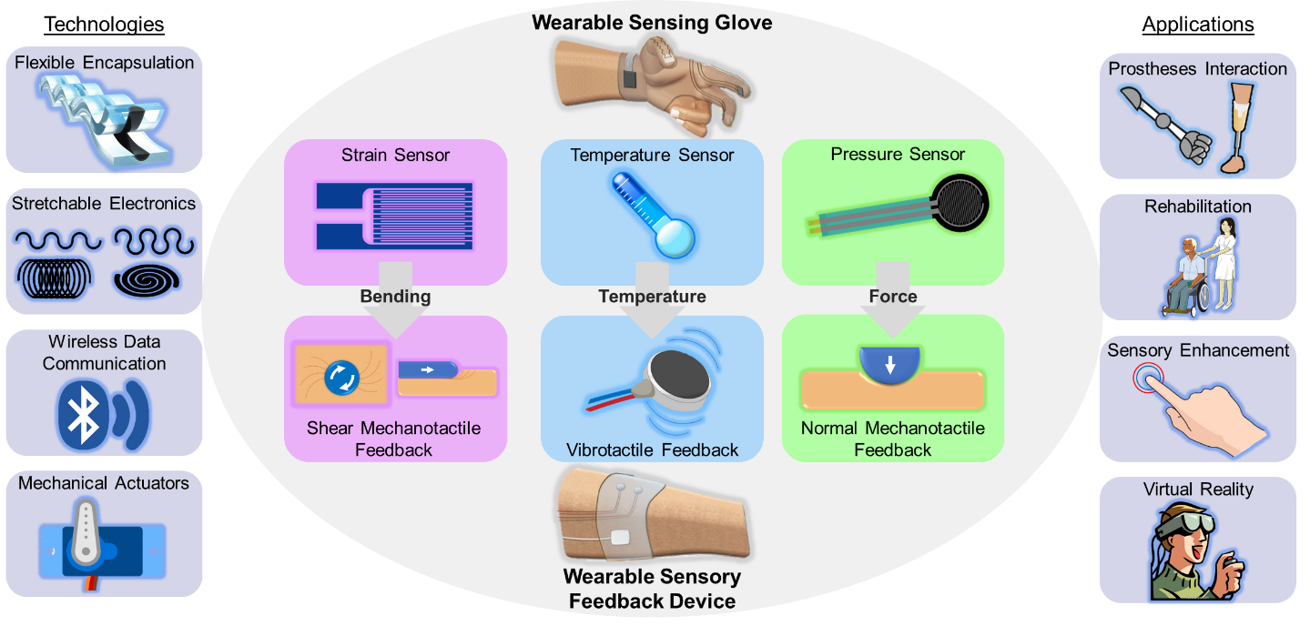

**Fig. 1 Integration of wearable sensory feedback devices with wearable sensing gloves for rehabilitation, virtual reality, sensory enhancement, and prostheses.** Flexible Encapsulation (Xu et al. 2018b). Stretchable Electronics (Rojas et al. 2017). Wireless Data Communication (ClipartLibrary 2021a). Mechanical Actuators (PinClipart 2021). Strain Sensor (AnonMoos 2012). Temperature Sensor (ClipartMax 2021a). Vibrotactile Feedback (ClipartMax 2021b). Pressure Sensor (Sparkfun 2021). Prosthetes Interaction (Moini 2011; OpenClipart 2018). Rehabilitation (GDJ 2019). Sensory Enhancement (ClipartLibrary 2021b). Virtual Reality (PNGKey 2021).

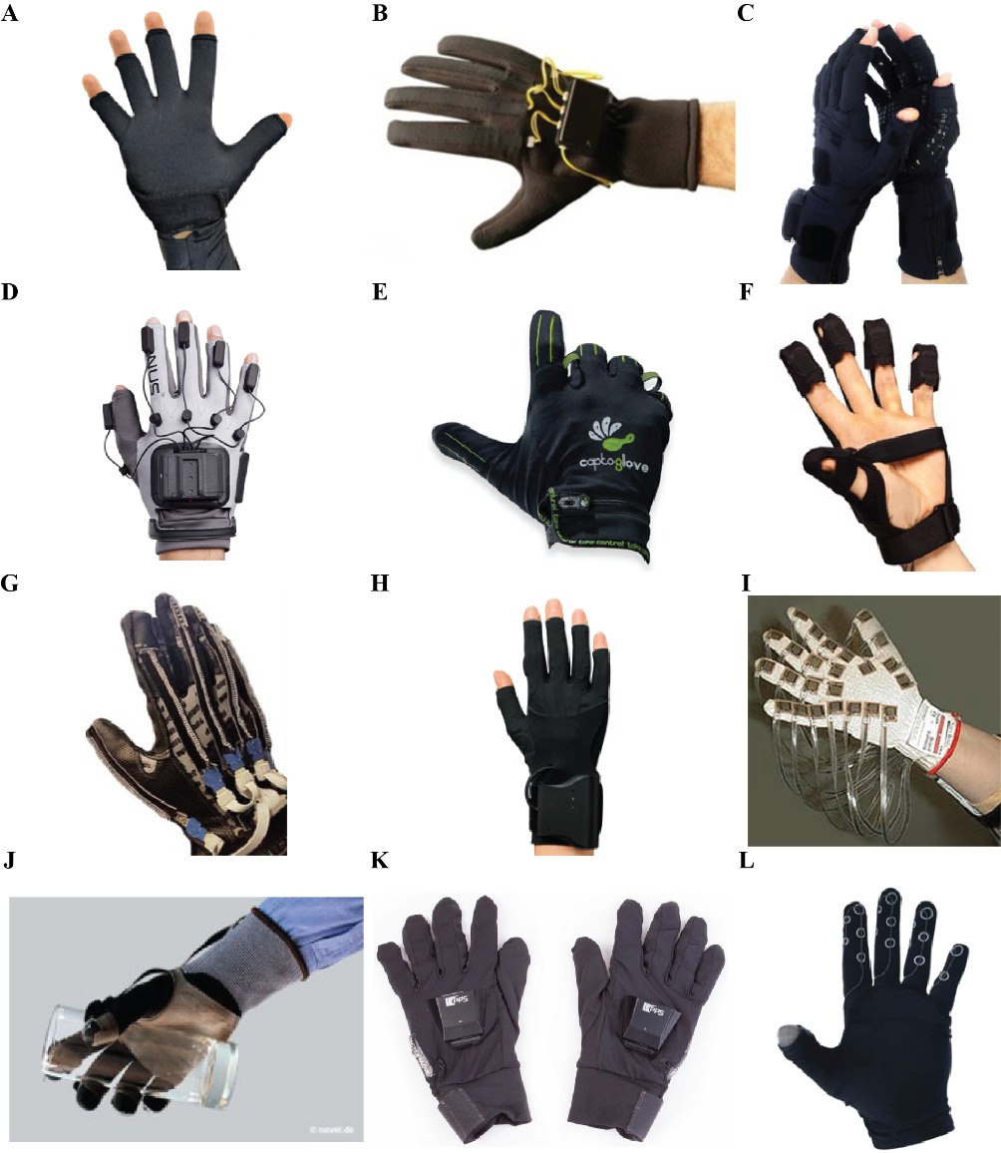

**Fig. 2 Examples of commercially available wearable gloves with embedded sensors.** (A) Image courtesy of 5DT Technologies (5DT 2021). (B) Image courtesy of Virtual Realities, LLC (Virtual Realities 2018). (C) Image courtesy of Sensor Holdings Limited (StretchSense 2021). (D) Image courtesy of Manus Machine BV (Manus-VR 2021). (E) Image courtesy of CaptoGlove Inc. (CaptoGlove 2020). (F) Image courtesy of Bebop Sensors (BeBop 2021). (G) Image courtesy of Flexpoint Sensor Systems, Inc. (Flexpoint 2021). (H) Image courtesy of MI.MU Gloves Limited (MimuGloves 2021). (I) Image courtesy of Vista Medical, Ltd. (Vista Medical). (J) Image courtesy of Novel GmbH (Novel 2021). (K) Image courtesy of Medical Tactile Inc. (PPS 2021b). (L) Image courtesy of Iron Will Innovations Canada Inc. (Peregrine 2021).

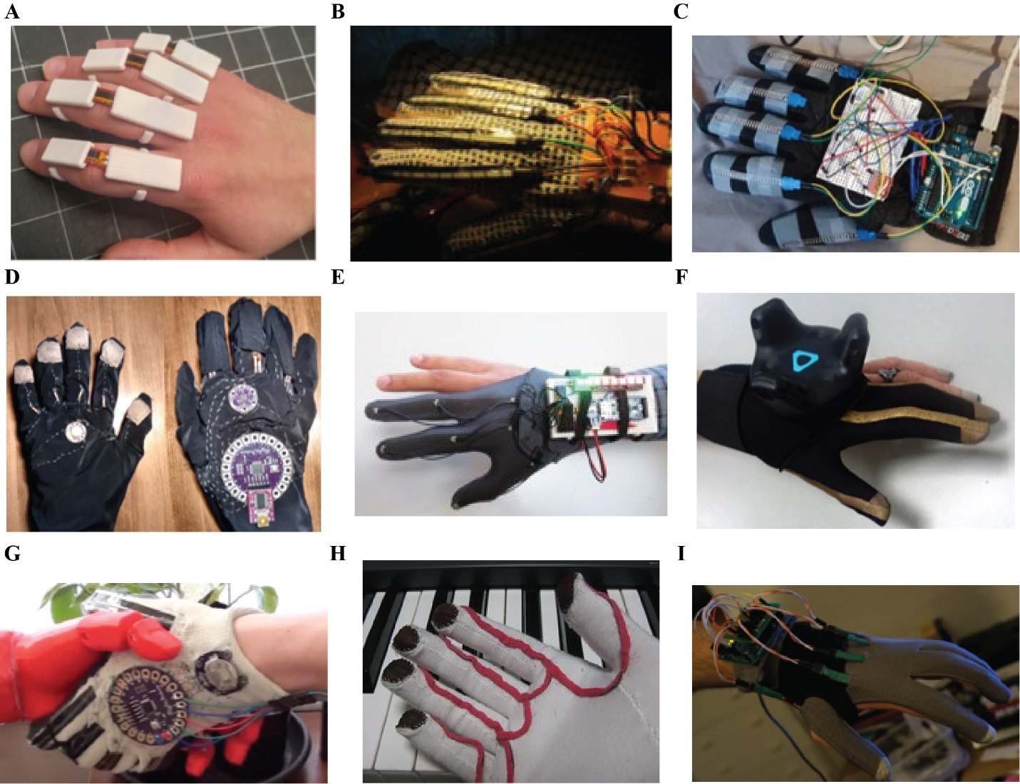

**Fig. 3. Examples of Do-It-Yourself prototypes of wearable sensor gloves with different sensors.** (A) Image courtesy from Thingiverse.com (Freedman 2016). (B) Image courtesy of Instructables.com (vu2aeo 2021). (C) Image courtesy of Instructables.com (Shja7942 2021). (D) Image courtesy of Instructables.com (Emcnany 2021). (E) Image courtesy of Instructables.com (Freire 2021a). (F) Image courtesy of Instructables.com (Freire 2021b). (G) Image courtesy of Instructables.com (Donaldson 2021). (H) Image courtesy of Instructables.com (Plusea 2021). (I) Image courtesy of Instructables.com (DanielE58 2021).

**Fig. 4. Multifunctional, soft, wearable sensing gloves with integrated temperature, pressure, and strain sensors.** (A) WSG with a strain sensor made from ethylene propylene rubber (Shen et al. 2016). (B) WSG with strain sensors made from a silver nanowire layer (Chen et al. 2016). (C) WSG with strain sensors made from carbon particles embedded in nitrile butadiene rubber (Qu et al. 2020). (D) WSG with pressure sensors made from potassium iodide and glycerol solution (Xu et al. 2019). (E) WSG with pressure sensors made from Interlink 402 force-sensitive resistors (Francés et al. 2019). (F) WSG with pressure sensors made from Galinstan conductive liquid (Hammond et al. 2014). (G) WSG with temperature sensors made from CNTs and [EMIM]Tf2N wrapped in conductive yarn encapsulated in Ecoflex (Wu et al. 2019). (H) WSG with temperature sensors made from off-the-shelf Ti TC77 ICs (Polishchuk et al. 2016). (I) WSG with temperature sensors made from MWNTs and PDMS (Li et al. 2020b). (J) Artificial skin with pressure, strain, and temperature sensors made from a single crystalline silicon nanoribbon (Kim et al. 2014).

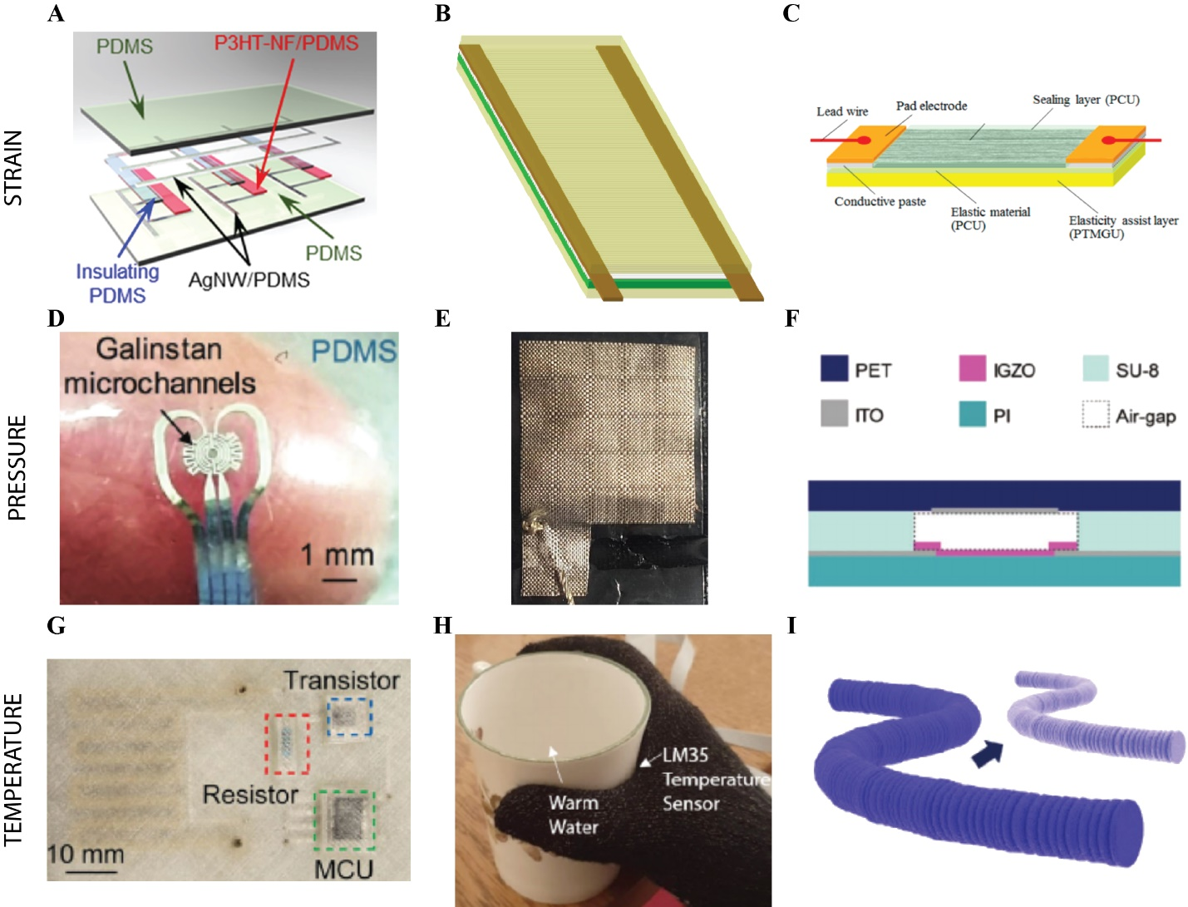

**Fig. 5 Examples of strain, pressure, and temperature sensors for integrating with wearable gloves.** (A) Strain sensor made from poly nanofibrils percolated in a silicone elastomer (Kim et al. 2018). (B) Strain sensor made from vinylidene fluoride nanofibers (Khan et al. 2018). (C) Strain sensor made from millimeter-long multiwalled CNTs (Suzuki et al. 2016). (D) Pressure sensor made from embedded Galinstan microchannels (Gao et al. 2017). (E) Pressure sensor made from anti-static sheets and conductive woven fabrics (Pizarro et al. 2018). (F) Pressure sensor made with air dielectrics to make a transparent and wearable pressure sensor array (Ji et al. 2020). (G) Temperature sensor made from liquid Galinstan material (Ota et al. 2016). (H) Temperature sensor made using Ti LM35 ICs (Hughes et al. 2020). (I) Temperature sensors made from strain‐insensitive fiber with compressed micro‐wrinkles (Lee et al. 2020).

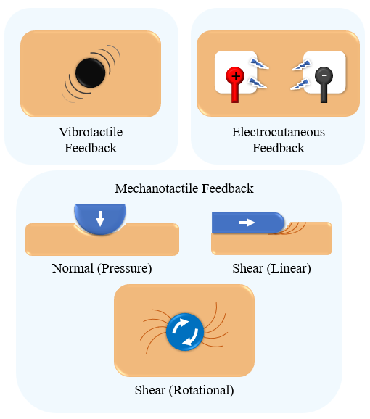

**Fig. 6 Examples of sensory feedback modes, including electrocutaneous, vibrotactile, and mechanotactile (normal or shear) methods.**

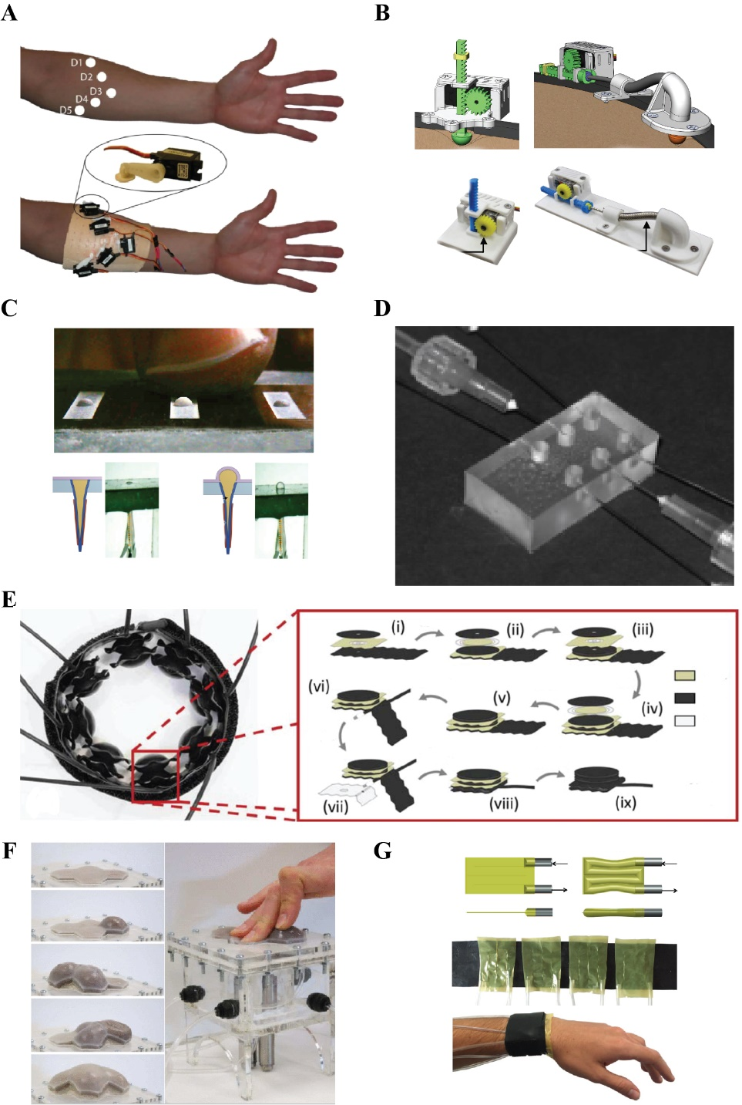

**Fig. 7 Examples of normal mechanotactile feedback actuators.** (A) Normal force applied through servos (Antfolk et al. 2012). (B) Normal force applied with a tactor actuated by a rack and pinion- left, and a Bowden cable- right (Schoepp et al. 2018). (C) Dielectric fluid actuated pouches for normal feedback (Han et al. 2020). (D) Balloon array for fingertip force feedback (King et al. 2007). (E) Normal force applied by pneumatic bellows creating squeeze (Young et al. 2019). (F) Geometry tactile display (Stanley et al. 2013). (G) Pneumatic wristband capable of pulsating (Raitor et al. 2017).

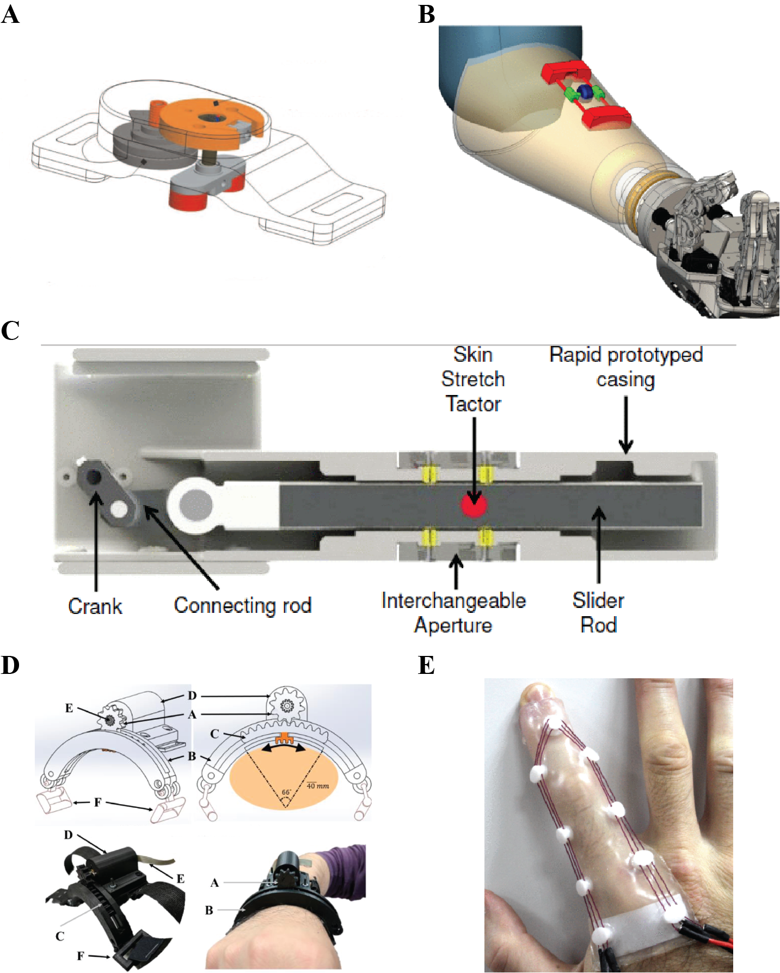

**Fig. 8. Examples of shear mechanotactile feedback actuators.** (A) Rotational skin stretch double head tactor (Wheeler et al. 2010). (B) Wheel lateral skin stretch wearable device (Rossi et al. 2018). (C) Finger pad skin stretch using a moving tactor (Schorr et al. 2013). (D) Lateral skin stretch wearable device for balance training (Pan and Hur 2017). (E) Soft skin stretch TCP actuated device (Chossat et al. 2019).

**Table 1. Examples of possible application types, categories, and rationale for uses of wearable sensing gloves.** This table includes the latest advancements and adapted materials from prior work (Dipietro et al. 2008).

|  |  |  |  |  |
| --- | --- | --- | --- | --- |
| **Application Type** | **Application Category** | **Rationale** | **Alternative Tool** | **Purpose** |
| Classical | Design & Manufacturing | Interact with computer-generated environments in a more natural way | Keyboard; Mouse; 3D Mouse | 3D Modeling; Virtual architecture; Virtual prototypes; Virtual training |
| Information visualization | Interact with data in a more natural way | Keyboard; Mouse | Scientific visualization; Manipulate scientific data audio-visual presentations; Manipulate data |
| Arts & Entertainment | Interact with computer-generated environments in a more natural way | Keyboard; Mouse | Computer-animated characters; Musical performance; Control Acoustic parameters; Video games; Light based artistic shows |
| Sign language recognition | Automatic translation | Keyboard; Mouse; Specialized video decoding | Communication systems for the deaf |
| Recent | Computer | Enhance computers’ portability | Keyboard; Mouse | Wearable Computers |
| Virtual reality | Interact with computer-generated environments; Perform digital movements in a more natural way | Keyboard; Mouse; Specialized Controller; Headset | Video games; Virtual control of objects; Virtual communication |
| Healthcare | Easy and direct measurement between the hand and the environment | Motion analysis system; Goniometer; Keyboard; Mouse; Clinical Observation | Motor rehabilitation; Sensory enhancement; Medical diagnostics; Surgery replication |
| Prosthetics | Improve control and adoption of prosthetic | Invasive nerve monitoring; Open loop feedback; Visual feedback | Prosthetic use; Prosthetic enhancement |
| Robotics | Control and program robots in a more natural way | Keyboard; Mouse | Mobile robots; Automation robots; Teach skills to robots in a natural way |
| Artificial intelligence | Detect hand movements and gesture recognition | Algorithms; Threshold detection; User action determination | Object detection; body position mapping; Human interaction modeling; Gesture recognition |

**Table 2. Summary of existing sensor technologies for implementing wearable sensing gloves.**

|  |  |  |  |  |
| --- | --- | --- | --- | --- |
| **Sensor** | **Sensor properties** | | | **Reference** |
| Material | Mechanical | Electrical |
| Temperature | Si, Au Nanoribbon in Polyimide | GF = 200; Fracture toughness = 1 MPa m1/2;  t = 110 nm | 10 mV/C | (Kim et al. 2014) |
|  | OTS Texas Instruments Contact Temperature Sensor | 2.80 mm x 2.95 mm | 0.0625 C/Bit using TC77 IC | (Polishchuk et al. 2016) |
|  | Carbon nanotubes and ionic liquid embedded in silkworm fiber yarn surrounded by Ecoflex | 0.76 mL of multiwalled CNT; 0.5 mL of ionic liquid | 1.23% C-1 | (Wu et al. 2019) |
| Pressure | OTS Interlink Electronics FSR | Piezoelectric sensor; 0.2” Diameter | 22 N/MΩ | (Polishchuk et al. 2016) |
|  | Silicone tubing filled with water | 2 mm diameter soft tubing | Pressure Delta = 3 – 100 Pa; sensitivity = 38.26 mV/kPa | (Hughes et al. 2020) |
|  | Si, Au Nanoribbon in Polyimide | GF = 200; Fracture toughness = 1 MPa m1/2;  t = 110 nm | Delta R/R0 %/Pressure kPa ~ 0.40 | (Kim et al. 2014) |
|  | Silicone based sensor with conductive liquid | 5.3% Hysteresis @ 1 Hz | 100% Resistance increase at 5 N; | (Xu et al. 2019) |
|  | Galinstan liquid metal in Ecoflex silicone rubber | H = 500 um, W = 300 um, L = 157.4 mm | Pressure sensitivity = 125 kPa / V | (Hammond et al. 2014) |
|  | Silver nanowires embedded in silkworm surrounded by Ecoflex | Ag NW L=25 um;  D=50 nm | 0.136 kPa -1 | (Wu et al. 2019) |
| Strain | EPR, Scotch Electrical Semi-Conducting Tape 13 | Elongation =<800%;  5 mm x 20 mm | Resistance change = 30.6% | (Shen et al. 2016) |
|  | Si, Au Nanoribbon in Polyimide | GF = 200; Fracture toughness = 1 MPa m1/2;  t = 110 nm | Delta R/R0 %/Strain % = 0.833 | (Kim et al. 2014) |
|  | Knitted piezoresistive fabric | 75% electroconductive yarn and 25% Lycra | < 5 Degree error | (Carbonaro et al. 2014) |
|  | Millimeter-long multiwalled Carbon Nanotubes | Elongation < 200%; fracture elongation ~ 500%; Elasticity Modulus = 2-5 MPa | Sensing delay < 15 ms; GF = 10.5; 300 Ω/% | (Suzuki et al. 2016) |
|  | OTS Flexion sensors | H = 0.43 mm; L = 112 mm; W = 6.35 mm | > 1 million cycles; Flat resistance = 10 kΩ | (Chen et al. 2021) |
|  | Galinstan liquid metal in Ecoflex silicone rubber | H = 500 um, W = 300 um, L = 97 mm | 1.58 N / V | (Hammond et al. 2014) |
|  | Conductive woven glove | Conductive knitted glove with insulated wire | 120 unique sensor readouts | (Hughes et al. 2020) |
|  | OTS Omega KFH-20-120-C1-11L1M2R Strain Gauge | Temperature Tolerance = 1/K; Elongation < 20,000 um/m | R = 120 Ω; GF = 2; | (Zhang et al. 2019) |
|  | Silicone based sensor with conductive liquid | Silicone Eco-Flex; E = 70 kPa; Failure Strain = 900% | GF = 2.2 @ 1 Hz | (Xu et al. 2019) |

**Table 3. Summary of vibrotactile feedback examples.**

|  |  |  |  |
| --- | --- | --- | --- |
| **Feedback Actuation** | **Purpose** | **Conclusions / main take-aways** | **Reference** |
| Miniature speaker to produce vibrations | Compare the effectiveness of visual, pressure and vibrotactile feedback when controlling a myoelectric hand | Vibrotactile + vision was preferred over vision alone, but pressure + vision was preferred over vibration + vision | (Patterson and Katz 1992) |
| Vibrotactile feedback using a smartphone | Use sensory feedback as a means of learning and rehabilitation for patients with gait issues | Feedback was effective at helping subject improve gait. | (Redd and Bamberg 2012) |
| 5 small vibrators placed in the shape of an open hand | Study the perception of vibrotactile and mechanotactile feedback on amputees | Spatial discrimination can be difficult when multiple vibrators are placed closely | (Antfolk et al. 2012) |
| Vibrating motors | Compare vibrotactile event-cue feedback vs. amplitude-based feedback for grasp force control | Feedback enhanced performance. Patients with more sever impairment preferred constant feedback while less affected patients preferred event-based feedback | (Jiang et al. 2009) |
| Vibrotactile feedback with vibration motors proportional to error | Use sensory feedback for motor learning (corrective feedback) | Immediate feedback is very important. Skin is most sensitive to frequencies around 250 Hz. Learning with feedback was more mentally demanding but it improved performance | (Lieberman and Breazeal 2007) |
| Vibration motors | Evaluate the effectiveness of vibrotactile feedback in preventing slip | Vibrotactile feedback was useful and necessary to prevent slip when visual feedback is not available | (Walker et al. 2014) |
| Vibrating motors | Provide force and proprioceptive feedback to control a cable driven gripper | Feedback allowed subject to perceive stiffness and control the gripper without visual feedback | (Lee et al. 2017) |

**Table 4. Summary of normal mechanotactile feedback examples.**

|  |  |  |  |
| --- | --- | --- | --- |
| **Feedback Actuation** | **Purpose** | **Conclusions / main take-aways** | **Reference** |
| Motor driven rack and pinion which pushes against the skin | Compare the effectiveness of visual, pressure and vibrotactile feedback when controlling a myoelectric hand | Vision enhances manipulation ability. Pressure feedback + vision was the most effective | (Patterson and Katz 1992) |
| 5 servo motors with an attached lever with a button, placed in the shape of an open hand | Evaluate effectiveness of a multiple point tactile feedback display on the forearm | Actuators need to be at least 4 cm apart to be distinguishable. High power consumption by servos. Feedback enhanced subject’s ability to perceive stimulus. | (Antfolk et al. 2010) |
| 5 servo motors with an attached lever with a button | Study the perception of vibrotactile and mechanotactile feedback on amputees | Spatial discrimination was better with mechanotactile feedback. Mechanotactile feedback was better to control grip. | (Antfolk et al. 2012) |
| Pressure feedback using 2 designs: linear (rack and pinion) and cable driven (rack pulls on a Bowden cable connected to push head). | Evaluate the effectiveness of two different pressure tractor designs for myoelectric hand control | Rack and pinion were more effective. | (Schoepp et al. 2018) |
| Membrane with dielectric fluid, which forms small bumps as voltage is applied across the membrane | Create a texture display for the fingertips | Minimum detectable pouch size is 124 µm | (Redd and Bamberg 2012) |
| Pressure Feedback wristband consisting of eight pneumatic bellows made from layers of polyurethane | Display uniform wrist squeeze | Bellows can exert over 10 N of force. Stiffness of bellows increases with pressure | (Young et al. 2019) |
| Pneumatic wristband able to provide squeeze and pulsations. Actuators are made from polyethylene | Provide haptic feedback for translation and rotation cues | Pulsations mimic vibrations but are less uncomfortable | (Raitor et al. 2017) |
| Variable stiffness and geometry tactile display using pneumatics and particle jamming. The device consists of hollow silicon cells filled with coffee grounds that solidifies as air is vacuumed out of the cell. | Tactile display with variable geometry and stiffness | More shapes can be created as cells are added. Device can be used for feedback in teleoperation | (Mitsuda et al. 2002) |

**Table 5. Summary of shear mechanotactile feedback examples.**

|  |  |  |  |
| --- | --- | --- | --- |
| **Feedback Actuation** | **Purpose** | **Conclusions / main take-aways** | **Reference** |
| Moving tactor stretched finger pad proportionally to force | Evaluate the potential of skin stretch at substituting kinesthetic feedback by discriminating stiffness | Skin stretch can provide force magnitude and direction feedback. Feedback was intuitively perceived | (Schorr et al. 2013) |
| Rotational skin stretch with two rotating pads actuated by an ultrasonic motor | Evaluation of rotational skin stretch for motion and position (proprioceptive) feedback from a prosthetic arm | Effective for proprioceptive feedback, usage of prosthesis was improved | (Wheeler et al. 2010) |
| Tactor stretches skin laterally along arm circumference | Sensory feedback during balance training | Feedback helped subjects control their body center of pressure | (Pan and Hur 2017) |
| Soft finger skin stretch device using twister and coiled polymer actuators | Create a soft, compliant, lightweight skin stretch feedback device | Task time was slower than vibrotactile feedback, but reaction time was the same | (Chossat et al. 2019) |
| Cart like device attached to the forearm runs a wheel along the skin | Communicate proprioceptive feedback | Good accuracy for object discrimination. Device was intuitively deciphered | (Rossi et al. 2018) |

**Table 6. Pros and cons of four different types of feedback modes.**

|  |  |  |  |
| --- | --- | --- | --- |
| **Modes** | **Pros** | **Cons** | **Actuators** |
| Vibrotactile | Inexpensive, lightweight, small, simple to implement | Causes desensitization and annoyance in the long term | Vibrating motor, miniature speaker |
| Electrotactile | Easily detectable, clear intensity levels, small | Uncomfortable, electric hazard | TENS, electrodes |
| Mechanotactile  (Pressure / Normal Force) | Modality matched, easily detectable, intuitive | Bulky, difficult to communicate intensity levels | Servo motor, rack and pinion, pneumatic actuators |
| Mechanotactile  (Skin Stretch / Shear Force) | Modality matched, easily detectable, communicates magnitude and direction, intuitive | Uncomfortable, dependent on skin-tactor contact, bulky | Belts, rotating buttons, wheels |